|  |
| --- |
| **Everi Holdings Inc. - for internal use only** |
|  |
| AUTOMATED CODE REVIEW |
|  |
| Enterprise Architecture |
| 10/10/2024 |
|  |
| © 2023 Everi Payments Inc. and/or its subsidiaries or affiliates (collectively, “Everi”). This is Everi’s proprietary and confidential material. No part of this material may be disclosed, in any manner, to another party without the prior written consent of Everi. |

|  |  |
| --- | --- |
|  |  |

# Control Page

|  |  |  |
| --- | --- | --- |
|  | |  |
| Title: | AUTOMATED CODE REVIEW | |
| Overview: | Automated Code Review Tool, Use Cases | |
| Author: |  | |
| Reviewer: |  | |
| Department: | Enterprise Architecture | |
| Issue Date: | 10/10/2024 | |

Table of Contents

Control Page 2

Introduction : Automated Code Review 7

Overview 7

Programming Languages Supported by Automated Code Review Tool: 8

• For Organization Standards files: 8

• For Code files: 8

Purpose 8

Objectives of the System 8

Who Can Benefit? 8

Key Features 9

1. Code Review: 9

2. Linting and Syntax Checks: 9

3. Code Comparisons: 9

4. Error Classification: 9

5. Severity Analysis: 9

6. URL Risk Classification: 9

System Requirements 10

Hardware Requirements 10

Software Requirements 10

Access Requirements 10

Dependencies 10

Internet Connection 11

Installation Guide 12

Step 1: Set Up Python Environment 12

Step 2: Clone the Repository 12

Step 3: Install Dependencies 12

Step 4: Configure API Keys 12

Step 5: Launch the Application 13

Testing the Installation 13

Optional Enhancements 13

Troubleshooting 13

Application Architecture 14

1 High-Level Architecture Overview 14

2 Detailed Architecture Components 14

2.1 Frontend (User Interface) 14

2.2 Backend (Code Review Processor) 15

2.3 GitHub Integration 15

2.4 AI/ML Models (Code Review and Language Models) 16

2.5 File Storage and Metadata 16

3 Data Flow and Interaction Diagram 17

4 Key Components Interaction 17

User Interface (UI) - Detailed Overview 18

1. UI Layout Structure 18

Header Section: 18

File Upload Section: 19

Code Review Options Section 19

GitHub Integration Section 20

Results Display Section 21

Footer Section 21

User Experience (UX) Considerations 22

UI Flow Diagram 22

Functionality of Automated Code Review 23

Modules and Code Structure 23

1. Import Libraries: 24

2. Loading Environment Variables: 24

3. Load Custom Modules: 24

4. Setup Groq API Client: 25

5. Streamlit UI Styling and Layout: 25

6. File Uploads and User Input: 25

7. Processing files: 26

8. Generate Code Review: 26

9. Error Analysis: 28

10. Optimization Recommendations: 29

11. Code Comparison and Highlighting: 31

12. Display of Code Changes: 32

13. Vulnerability Detection in Code: 32

14. Metrics to Calculate Score: 33

15. Classify Urls: 35

16. Determine Severity: 36

Use Cases for Automated Code Review 38

FOR ONLY NEW FILE 38

1. Upload File for Code Review: 38

2. Type of Review: 38

3. Code Review: 39

4. Error Reporting and Vulnerabilities Analysis: 40

5. Optimization Recommendations: 41

6. Security Review: 43

FOR BOTH FILES (CHANGES) 44

1. Upload Files for Code Review: 44

2. Type of Review: 45

3. Feature Comparison: 45

4. Code Review: 46

5. Error Reporting and Vulnerabilities Analysis: 47

6. Code Style Enforcement: 48

7. Optimization Recommendations: 49

FOR FOLDERS 51

1. Folder Upload for Analysis: 51

2. Navigate and Select Specific Files: 52

3. Batch Code Review: 52

4. Aggregate Error Reporting: 52

5. Vulnerability Analysis Across Files: 54

6. Optimization Recommendations per File: 55

FOR GITHUB REPOSITORIES 57

1. Connect to Github Repository: 57

2. Navigate Through Folders and Files: 58

3. Select Files for Review: 59

4. Batch and Individual Code Reviews: 59

5. Error Reporting and Vulnerabilities Analysis: 60

FOR GITHUB PULL REQUEST 61

GitHub Authentication and Repository Access: 62

Fetch and Display Open Pull Requests: 62

File Changes in the PR (Diff): 63

Code Review and Merge: 63

Display Detailed PR Review (Optional): 65

FOR AZURE DEVOPS REPOSITORIES 68

1. Connect to Azure DevOps Repository: 68

2. Navigate Through Project Structure: 68

3. Batch Analysis Across Files: 69

4. Error Classification and Severity Analysis: 70

5. Vulnerability Detection in Repository Files: 70

6. Report Optimization and Improvements: 71

Appendix 72

Environment Variable Configuration 72

# Introduction : Automated Code Review

## Overview

The Automated Code Review System is a cutting-edge tool designed to streamline the process of code analysis, ensuring high-quality, secure, and maintainable software development. By leveraging advanced technologies, including Large Language Models (LLMs), this system automates the traditionally manual and time-consuming process of reviewing code, making it faster, more accurate, and accessible to both technical and non-technical stakeholders.

This tool addresses multiple facets of software quality, including identifying code errors, enforcing organizational coding standards, detecting vulnerabilities, and suggesting improvements. Its user-friendly interface and robust integration capabilities make it a versatile solution for individual developers, team collaborations, and enterprise-level projects.

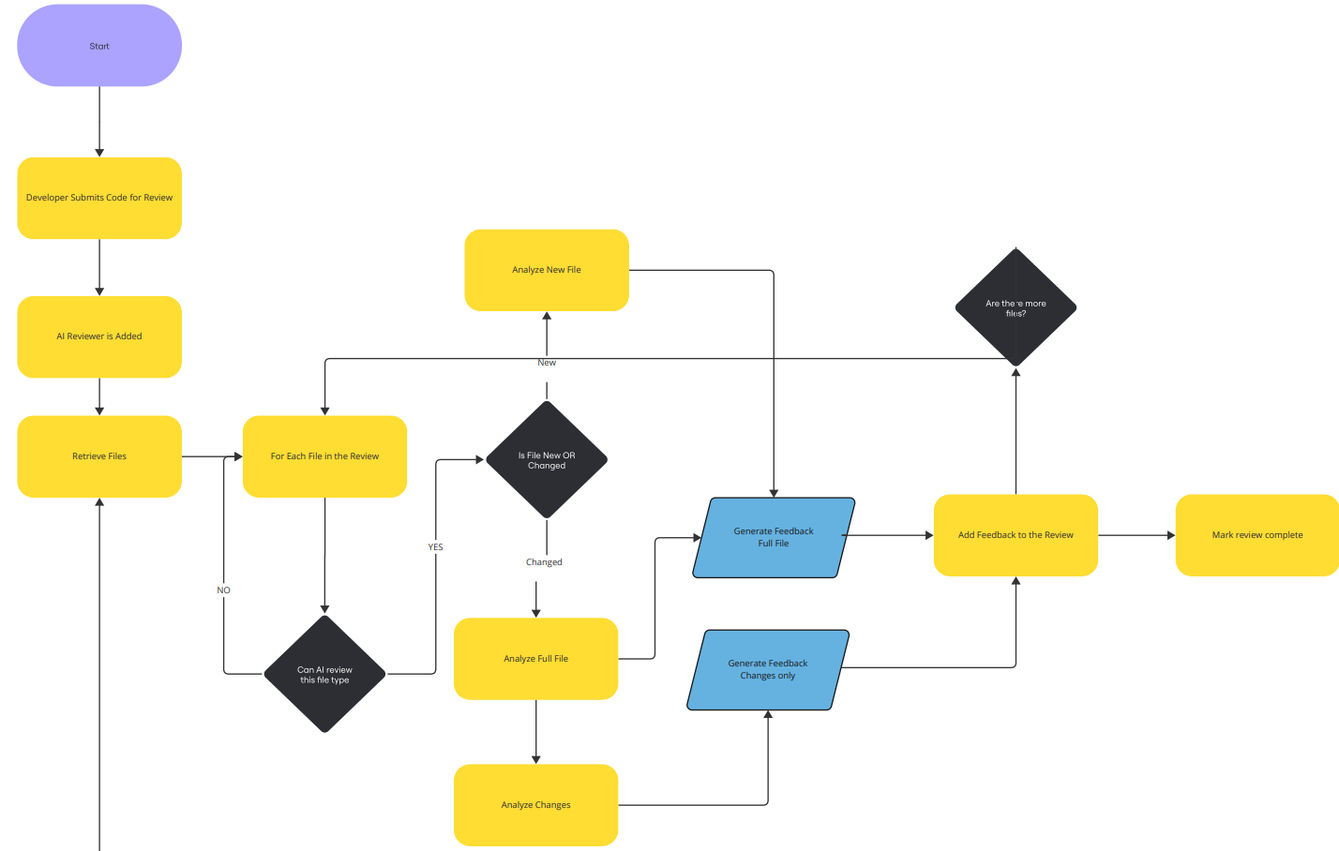

### Programming Languages Supported by Automated Code Review Tool:

### For Organization Standards files:

* Word Document
* PDF Document
* PPT Document
* Text Document

### For Code files:

|  |  |
| --- | --- |
| * JAVASCRIPT | * SQL |
| * PYTHON | * .NET |
| * JAVA | * C |
| * HTML | * CSS |
| * C++ |  |

## Purpose

This document provides a comprehensive guide for understanding, installing, and using the Automated Code Review System. The system is designed to streamline the code review process by analyzing source code for errors, vulnerabilities, and compliance with organizational coding standards. It supports integration with GitHub, Azure DevOps (ADO), and manual uploads for enhanced flexibility.

## Objectives of the System

1. **Enhance Code Quality:** Automates the identification and resolution of potential issues, ensuring robust and error-free code.
2. **Improve Efficiency:** Reduces manual effort in code reviews, freeing up developers to focus on feature development and innovation.
3. **Ensure Consistency:** Enforces uniform coding standards across teams and projects.
4. **Bridge the Gap Between Stakeholders:** Offers both technical and non-technical perspectives, making the review accessible to developers and clients alike.
5. **Support Agile Development Practices:** Fits seamlessly into Agile workflows by enabling quick and iterative code reviews.

## Who Can Benefit?

1. **Developers:** Gain detailed feedback on code issues, vulnerabilities, and performance bottlenecks.
2. **Team Leads/Managers:** Monitor team adherence to coding standards and ensure project quality.
3. **Non-Technical Stakeholders:** Understand high-level insights into code quality without requiring technical expertise.
4. **Enterprises:** Ensure security, compliance, and scalability across large-scale projects.

## Key Features

### Code Review:

The code review process generates a detailed review based on the code provided and organizational standards. If no changes are specified, it requests a concise summary of the new code's functionality. This explanation is obtained by sending a prompt to an AI model, which analyzes the code and returns a clear description of its purpose and operations. This approach helps developers understand the intent behind the code while maintaining clarity and focusing on key aspects, ultimately enhancing the review process by providing immediate insights into the code’s functionality.

### Linting and Syntax Checks:

Provides robust linting and syntax validation for multiple programming languages, including Python, Java, JavaScript, HTML, CSS, and SQL. This feature helps catch potential syntax errors, enforces coding style guides, and ensures compliance with language-specific standards before code is committed.

### Code Comparisons:

Enables developers to compare different versions of code by visually highlighting changes such as additions, deletions, and modifications. This feature makes it easier to track the evolution of code over time, identify accidental regressions, and understand the nature of updates between versions.

### Error Classification:

Automatically categorizes detected errors based on their type—whether they are syntax errors, logical flaws, runtime issues, or potential security vulnerabilities. This allows developers to prioritize fixes and approach debugging in a structured and efficient way.

### Severity Analysis:

Assesses the severity of identified issues, assigning a level of criticality to each. This feature helps developers focus on addressing high-priority issues that may lead to significant performance bottlenecks, security risks, or functionality breaks.

### URL Risk Classification:

Scans URLs embedded in the code for potential risks, identifying those that might expose the system to vulnerabilities such as phishing, malware, or insecure connections. This feature provides security recommendations to mitigate the risks associated with using untrusted or unsafe URLs.

# System Requirements

Before installing the **Automated Code Review System**, ensure that the system meets the following prerequisites:

## Hardware Requirements

* **Processor:** Quad-Core CPU or higher (Intel i5/AMD Ryzen 5 or equivalent).
* **RAM:** Minimum 8 GB (16 GB recommended for optimal performance).
* **Storage:** At least 10 GB free disk space for installation and temporary file storage.
* **GPU (Optional):** For LLM-based operations, a GPU with CUDA support (NVIDIA GTX 1060 or higher) is recommended for faster processing.

Software Requirements

* **Operating System:**
  + Windows 10/11 (64-bit)
  + macOS 10.15 (Catalina) or later
  + Linux (Ubuntu 20.04 or later, Red Hat, or equivalent distributions)
* **Python Version:** Python 3.9 or later.
* **Package Manager:** pip (comes pre-installed with Python).
* **Virtual Environment:** Recommended to use venv or conda for dependency isolation.

## Access Requirements

* GitHub Token: For repository and pull request integration.
* Azure DevOps Access Token: For ADO pipeline analysis.

## Dependencies

The system requires the following Python libraries and tools:

* **Core Libraries:**
  + streamlit (for the UI)
  + pandas (for data processing)
  + numpy (for numerical computations)
* **Language Models & APIs:**
  + openai (for LLM-based reviews)
  + langchain (for advanced LLM integration)
* **Version Control Integration:**
  + PyGithub (for GitHub API access)
* **Web Framework:**
  + fastapi (optional for RESTful API integration)
* **Others:**
  + regex, json, and os for file handling and pattern matching.

## Internet Connection

* A stable internet connection is required to:
  + Access LLM APIs (e.g., OpenAI).
  + Clone repositories from GitHub.
  + Retrieve updates and patches.

# Installation Guide

Follow these step-by-step instructions to install the Automated Code Review System on your local machine.

### Step 1: Set Up Python Environment

**Verify Python Installation:**

* Open a terminal/command prompt and run:
  + ***python –version***
* Ensure the version is 3.9 or later.

**Install a Virtual Environment:**

* Run the following command to create and activate a virtual environment:
* ***python -m venv env***
* ***source env/bin/activate # On macOS/Linux***
* ***env\Scripts\activate # On Windows***

### Step 2: Clone the Repository

**Clone the project repository from GitHub:**

* *git clone* [*https://github.com/Sravya-Sree/Auto-code-review.git*](https://github.com/Sravya-Sree/Auto-code-review.git)
* *cd Auto-code-review*

### Step 3: Install Dependencies

**Install the required libraries from the requirements.txt file:**

* *pip install -r requirements.txt*

**(Optional) Install additional dependencies if needed:**

* *pip install streamlit langchain openai pandas numpy PyGithub*

### Step 4: Configure API Keys

**Obtain API keys for required services:**

* OpenAI API Key: Sign up at [**OpenAI**](https://openai.com/) and retrieve your API key.
* (Optional) GitHub API Key: Generate a Personal Access Token from your GitHub account.

**Store the keys securely:**

* Add the keys to a .env file in the root directory:
* ***env***
* ***OPENAI_API_KEY=your_openai_api_key***
* ***GITHUB_TOKEN=your_github_token***

### Step 5: Launch the Application

**Start the Streamlit application:**

* ***streamlit run app.py***

Access the application in your browser at <http://localhost:8501>.

### Testing the Installation

1. Upload a sample code file to test the review system.
2. Test GitHub repository integration by providing a valid repository URL.
3. Verify output sections for:
   * Error analysis (syntax, compilation, runtime, logical).
   * Vulnerability detection.
   * Code improvement suggestions.

### Optional Enhancements

* **Deploy the Application on a Server:**

Use services like AWS, Azure, or Heroku to host the application for team-wide access.

* **Dockerize the Application:**

Create a Dockerfile for containerized deployments:

* *FROM python:3.9-slim*
* *WORKDIR /app*
* *COPY . .*
* *RUN pip install -r requirements.txt*
* *CMD ["streamlit", "run", "app.py"]*

### Troubleshooting

* **Dependency Errors:**  
  Ensure all dependencies are correctly installed. Run pip list to verify.
* **API Key Issues:**  
  Check if the .env file is correctly configured and loaded.
* **Port Conflicts:**  
  If port 8501 is already in use, specify a different port:
* streamlit run app.py --server.port=8502
* **GitHub Integration Issues:**  
  Ensure the GitHub token has the necessary permissions to access repositories.

By following this guide, you'll have the **Automated Code Review System** installed and ready for use in a professional development environment.

# Application Architecture

The Automated Code Review System is designed with a modular, scalable, and maintainable architecture that ensures seamless integration with various systems and APIs, while providing a robust user interface for code analysis. Below is a detailed breakdown of the architecture components and their interactions:

## 1 High-Level Architecture Overview

At a high level, the application follows a **Client-Server Architecture** with the following primary components:

* **Frontend (Client)**: The user interface, built with **Streamlit**, interacts with the user, accepts file inputs, and displays results.
* **Backend (Server)**: The backend processes user inputs, handles API integrations, and performs code review analysis. The backend is implemented in Python and uses various AI models for code review.
* **Database/Storage**: Stores configurations, logs, and metadata such as file uploads, user data, and analysis history.
* **External APIs**: Third-party services like **OpenAI** for code review generation, **GitHub API** for fetching repository files, and other AI/ML models for vulnerability detection and code analysis.

## 2 Detailed Architecture Components

### 2.1 Frontend (User Interface)

* **Streamlit UI** serves as the frontend for user interaction.
  + **File Uploaders**: Users can upload code files (e.g., C, C++) and configuration files (e.g., code standards, old code for comparison).
  + **Buttons/Dropdowns**: To trigger different actions, such as reviewing a new file, comparing changes, or fetching code from GitHub.
  + **Results Display**: Displays the results of the analysis, including error types, suggestions, and vulnerabilities.
  + **User Input Sections**: Options for configuring the level of review (e.g., Developer vs. Client).

#### Data Flow:

* User uploads the code files and configuration through the UI.
* Actions are triggered by buttons (e.g., “Submit”, “Compare Old and New”).
* The system processes the files on the backend and returns the review results to the frontend.

### 2.2 Backend (Code Review Processor)

* **Flask/FastAPI (Optional)**: A Python-based backend server that handles incoming requests, processes them, and returns responses. Streamlit communicates with the backend to send and receive data.
* **Code Analysis Logic**:
  + **Error Detection**: Syntax, compilation, runtime, and logical errors are identified using regex, custom parsers, or static analysis tools.
  + **Vulnerability Detection**: Integration with security APIs or custom analysis to detect security flaws in the code.
  + **Code Improvement Suggestions**: A language model (e.g., OpenAI or a custom-trained LLM) generates suggestions for improving the code based on error analysis and security recommendations.

#### Core Features:

* **Error Analysis**: Detects various types of errors (syntax, compilation, runtime, and logical errors) based on the uploaded code file.
* **Vulnerability Detection**: Uses external AI models or static analysis tools to identify potential security flaws or vulnerabilities in the code.
* **Code Improvement**: Suggests ways to improve the code, following best practices and security guidelines.
* **Integration with LLMs**: The system connects to OpenAI or similar LLM APIs to generate human-readable code explanations and improvements.

#### Data Flow:

* The frontend sends the uploaded file (and old file, if any) to the backend for analysis.
* The backend performs error detection, vulnerability scanning, and code improvement using predefined rules or LLM-based processing.
* Results are sent back to the frontend for display.

### 2.3 GitHub Integration

* The system is capable of fetching code directly from **GitHub repositories**.
* **GitHub API**:
  + **Repository Access**: The system uses a **GitHub Personal Access Token** to authenticate and access public or private repositories.
  + **File Listing**: The system retrieves folder and file names from a given repository URL and displays them to the user.
  + **File Download**: The user can select a file from the repository for review, and the system downloads the file for analysis.

#### Data Flow:

* The user enters a GitHub repository URL.
* The backend uses the GitHub API to retrieve the list of files/folders and presents them to the user.
* The user selects a file, and the backend fetches the file for further analysis.

### 2.4 AI/ML Models (Code Review and Language Models)

* **OpenAI or LLM Integration**: The system uses **OpenAI GPT models** or other language models for generating detailed explanations, code suggestions, and improvements.
  + **Code Review Generation**: The AI model analyzes the code and generates explanations for errors, warnings, and suggestions.
  + **Vulnerability Detection**: A specialized model or integration with a tool (e.g., Bandit for Python, or custom security models) scans the code for vulnerabilities.
  + **Contextual Understanding**: The AI models understand the context of the code, offering relevant and practical suggestions for improvement.

#### Data Flow:

* The backend sends the code to the AI models.
* The model processes the code and returns a set of errors, suggestions, and potential vulnerabilities.
* The AI model uses the context (e.g., function names, variables) to provide human-readable feedback.

### 2.5 File Storage and Metadata

* The system stores uploaded files and analysis results in a **local database** or cloud storage (e.g., AWS S3 or Google Cloud Storage).
* **Metadata Storage**: Logs information about users, file uploads, analysis results, and timestamps for later retrieval.
* **File Storage**:
  + Code files are stored temporarily for analysis.
  + Old and new code files (if provided) are saved for comparison.

## 3 Data Flow and Interaction Diagram

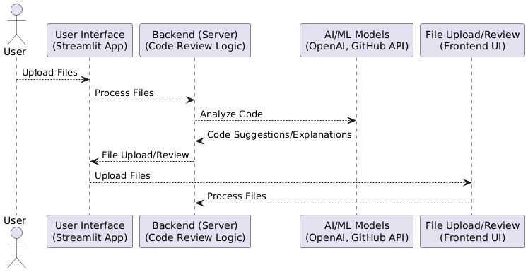

## 4 Key Components Interaction

**Frontend (Streamlit UI) and Backend (Python Server)**

* **Communication:** Frontend communicates with the backend via HTTP requests (using FastAPI or Flask for RESTful APIs).
* **File Upload and Data Transfer:** Files are uploaded via Streamlit's file uploader widget and passed to the backend for processing.
* **Action Triggering:** Button actions in the frontend trigger analysis or repository fetching from GitHub.

**Backend and AI/ML Integration**

* The backend passes code files to the AI/ML models (via APIs like OpenAI) for review.
* **Code Review Process:** The backend processes the model’s response, formats it, and sends it back to the frontend.

**GitHub Integration**

* **Repository Interaction:** The backend fetches files from GitHub repositories, allowing users to select and review files directly from remote repositories.

# User Interface (UI) - Detailed Overview

The User Interface (UI) for the Automated Code Review System is built using Streamlit, a Python framework that allows rapid development of interactive web applications. The goal of the UI is to provide an intuitive, user-friendly platform where users can easily upload code files, receive feedback, and interact with various system features.

Below is a detailed breakdown of the various UI components and their functionalities:

## 1. UI Layout Structure

The UI is designed to be clean, easy to navigate, and responsive. It is divided into the following sections:

1. **Header Section**
2. **File Upload Section**
3. **Code Review Options Section**
4. **GitHub Integration Section**
5. **Results Display Section**
6. **Footer Section**

### Header Section:

**Purpose**: To introduce the application and provide basic navigation for users.

**Components**:

* **Application Title**: A prominent title (e.g., "Automated Code Review System") displayed at the top of the page.
* **Logo**: An optional logo representing the company or application, placed alongside the title.
* **Navigation Bar** (if required): A top navigation bar with links (e.g., **Home**, **Documentation**, **About Us**) for easy access to additional resources.

**Design Considerations:**

* The header is kept simple yet informative.
* It will be consistent across all pages, ensuring a familiar experience for users.

File Upload Section:

The **File Upload Section** is the core functionality where users upload their code files for review. It allows users to submit files that need to be analyzed.

* **File Upload Options**:
  + **Code File Upload**:
    - The user can upload files in specific programming languages (e.g., C, C++) for review.
    - The file upload widget supports multiple file types, and checks for file extensions (e.g., .c, .cpp).
    - Streamlit’s built-in file uploader widget is used to receive the file.
  + **Old Code File Upload (Optional)**:
    - If the user wants to compare the current code with a previous version, they can upload the **old code file**. This is an optional field.

**Components**:

* **Upload Button**: A button allowing users to select and upload their files.
* **File Extension Validation**: The UI will validate that the files uploaded are of valid types (C, C++).
* **Feedback on Upload Success**: A small notification or message confirming that the file has been successfully uploaded or if there was an issue (e.g., incorrect file type).

**Design Considerations**:

* The upload section is kept intuitive, with clear instructions for the user to understand which files are required and which are optional.

### Code Review Options Section

This section allows the user to configure the code review and control how the review is performed. It offers options to tailor the review based on the user’s needs.

* **User Type Selection**:
  + **Dropdown/Radio Buttons for User Type**: Users can select whether they are a **Developer** or a **Client**.
    - **Developer**: The system will provide a detailed technical review, including error types, line numbers, and suggestions.
    - **Client**: The review is simplified, focusing more on high-level feedback without delving into code-specific details.
  + **Button to Trigger Code Review**: After uploading the file and configuring the user type, the user clicks a button to trigger the code review.
* **Code Review Type**:
  + **New File Analysis**: Users can choose to analyze the newly uploaded file.
  + **Old vs. New Code Comparison**: If an old code file is provided, users can choose to compare the new file with the old one. This will highlight the differences and suggest improvements.

**Components**:

* **Dropdown/Radio Button for User Type**: A widget to select between Developer and Client.
* **Action Buttons**: Buttons such as "Analyze Code", "Compare Files", etc.
* **Text Box/Instructions**: Additional information or guidance on how to upload files and select review options.

**Design Considerations**:

* The options section is made collapsible to ensure the UI remains clean and uncluttered, but users can easily access the settings when needed.

### GitHub Integration Section

The **GitHub Integration Section** allows users to fetch code directly from **GitHub repositories**.

* **Repository URL Input**:
  + Users can enter a **GitHub repository URL**.
  + The system uses the GitHub API to fetch a list of files and folders from the specified repository.
* **Display Files and Folders**:
  + After entering the repository URL, the UI displays the available files and folders in a clickable format.
  + The user can select specific files for review.

**Components**:

* **GitHub URL Input**: A text input field where users can paste the URL of a public or private GitHub repository.
* **File Listing**: A dynamic list of files and folders from the repository that the user can click to select the file for analysis.
* **Authentication for Private Repos**: If the repository is private, the UI prompts users to enter their GitHub credentials or authenticate via OAuth.

**Design Considerations**:

* Ensure that the file list is user-friendly, and the UI is responsive so that it works across various devices and screen sizes.

Results Display Section

Once the code is uploaded and analyzed, the results are displayed in this section. The **Results Display** is divided into multiple sections, depending on the user type and selected review options.

* **Error Breakdown**:
  + **Syntax Errors**: Display a list of detected syntax errors, with the line number, error type, and suggestion for fixing it.
  + **Compilation Errors**: List of errors related to compiling the code (if applicable).
  + **Runtime Errors**: If the code has runtime issues, they are listed along with a suggestion for troubleshooting.
* **Code Vulnerabilities**:
  + If vulnerabilities are detected (e.g., SQL injection, buffer overflows), the UI displays these in a separate section.
* **Improvement Suggestions**:
  + The system generates suggestions for improving the code, including coding best practices, refactor suggestions, and security recommendations.
* **Comparison Results** (for Old vs. New File Analysis):
  + The differences between the old and new code are shown side by side or in a summary format, highlighting the added, removed, or modified sections.

**Components**:

* **Error and Vulnerability Lists**: Dynamic, expandable lists showing each detected issue along with its details.
* **Code Snippets**: Display a snippet of the problematic code (with line numbers) for context.
* **Improvement Suggestions**: Text sections with suggestions for code improvement.

**Design Considerations**:

* The results display is designed to be easily scannable and visually distinct, with color-coded highlights to emphasize critical issues (e.g., red for errors, yellow for warnings).
* For developers, a technical breakdown of the code is provided, while for clients, the results are simplified to avoid technical jargon.

### Footer Section

* **Purpose**: To provide additional information about the application, including links to the documentation, support, and contact details.
* **Components**:
  + **Copyright Information**: The footer displays copyright or licensing information.
  + **Links**: Links to related resources, such as documentation, FAQs, and customer support.

**Design Considerations**:

* The footer is kept minimal and unobtrusive, ensuring that it does not detract from the main content.

User Experience (UX) Considerations

* **Responsive Design**: The UI is fully responsive, ensuring that it works seamlessly across devices (e.g., desktop, tablet, and mobile).
* **Clear Navigation**: The user experience is streamlined to ensure that the user can easily navigate through the file upload, configuration, and result display stages.
* **Error Handling and Feedback**: The system provides clear and immediate feedback on any errors or issues during file upload, processing, or analysis.
* **Accessibility**: The UI adheres to basic accessibility standards, such as readable fonts, high contrast elements, and keyboard navigability.
* **Performance Optimization**: The app is optimized to handle large files efficiently, with minimal delays in analysis and result rendering.

### UI Flow Diagram

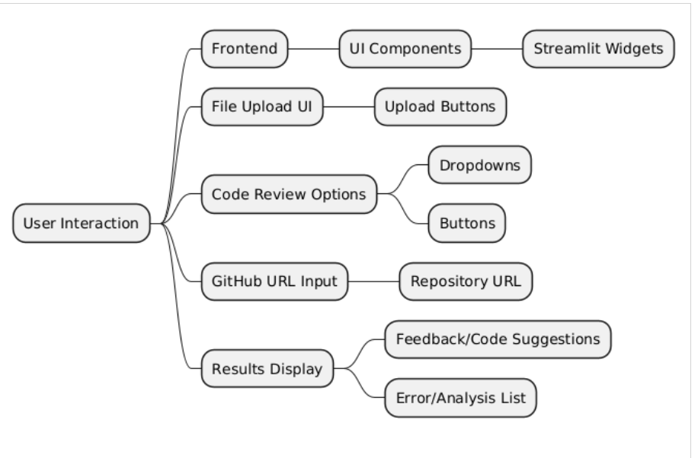

# Functionality of Automated Code Review

The **Automated Code Review System** is designed to perform seamless code reviews, detect errors, suggest improvements, and identify vulnerabilities. This system allows users to upload code files, compare old and new code versions, and generate insightful reports. The workflow ensures that every action taken by the user is systematically processed through various stages, each involving critical functions.

Modules and Code Structure

**Directory Structure**

project_directory/

│

├── ado.py # ADO integration logic

├── compare.py # File comparison logic

├── config.py # Configuration settings

├── folder_review.py # Folder analysis

├── metrics.py # Severity scoring and metrics

├── pr.py # Pull request analysis

├── prompt.py # Review prompt generation

├── repo_review.py # GitHub repository handling

├── styles.py # UI styling

├── main.py # Entry point for Streamlit application

├── utils/ # Utility functions

│ ├── file_processing.py

│ ├── text_truncation.py

│ └── vulnerability_detection.py

├── assets/ # Static assets (images, CSS)

├── requirements.txt # Dependencies

└── README.md # Documentation

### Import Libraries:

This section imports all the required libraries and modules necessary for the automated code review system.

**Details**:

* + *dotenv:* Loads environment variables from a .env file into your application’s environment, such as API keys, credentials, and configuration values.
  + *streamlit:* Used to build an interactive web application. Streamlit simplifies creating a user interface for uploading files, displaying results, and interacting with the NLP model.
  + *langchain & openai:* Integrate NLP capabilities into the code review system, enabling it to generate insights or reviews by analyzing the uploaded code.
  + *pdfplumber, docx, pptx:* Libraries to read text from various file formats (PDF, Word, PowerPoint). These are important to extract the content of documents that may hold organization standards or code files.
  + *SequenceMatcher:* Compares two sets of data (e.g., old and new code) to highlight differences.
  + *subprocess:* Executes shell commands, like running code linters or other external tools, to assess the quality of the code.
  + *re (Regular Expressions):* Used for pattern matching, such as searching for specific coding patterns that might introduce errors or vulnerabilities.

### Loading Environment Variables:

To safely load sensitive information like API keys and configuration values that should not be hard-coded into the application.

**Explanation**:

* + **load_dotenv()**: This function reads from a .env file, loading any defined variables into the environment, making them accessible to your Python code. For instance, the OpenAI or Groq API keys needed to make authenticated requests to their services.

### Load Custom Modules:

This section imports project-specific modules that provide essential functionality for error handling, prompts, and metric calculations.

**Explanation**:

* + **config**: Centralized settings such as API keys or file paths that are reused across the code.
  + **Errors**: Custom functions for handling various error conditions like file upload failures, unsupported file types, etc. These functions ensure that the system handles exceptions gracefully.
  + **prompt**: Contains the template or structure for prompts sent to the LLM. This could include questions about the code file, security vulnerabilities, or general quality assessments.
  + **metrics**: Functions for calculating statistics such as the number of errors, severity levels, or other code health indicators. These metrics help quantify the output of the code review system.

### Setup Groq API Client:

Initializes the API client for Groq, allowing the application to interact with an NLP model for performing code review tasks.

**Explanation**:

* The Groq API requires an authentication key (GROQ_API_KEY) to access its language models. By setting up the client, you prepare the system to send code data for analysis, asking the model to review code, detect issues, and offer suggestions.
* **Interaction with Groq**: After setting up the client, you'll later use this client object to send the uploaded files to the Groq model and retrieve responses (like code insights or reviews).

### Streamlit UI Styling and Layout:

Customize the look and feel of the Streamlit UI, ensuring the application is visually appealing and user-friendly.

**Explanation**:

* + **Custom CSS**: Styling the UI elements of the Streamlit app (e.g., background color, font size, button appearance) to match the aesthetic of your organization or provide a professional feel.
  + **HTML injection**: By using st.markdown(), you inject HTML and CSS code directly into Streamlit to apply more advanced styles. This can be helpful for ensuring consistency and branding across your application.

### File Uploads and User Input:

Provide users with an interface for uploading the necessary files (new code, old code, and organizational code standards). Users also choose the depth of review.

**Explanation**:

* + **st.file_uploader()**: A widget that allows users to upload files. In this case, the system requires at least a code file and optionally an old code file for comparison. The user can also upload the organization's coding standards in various formats (e.g., .docx, .pdf).
  + **st.selectbox()**: Allows users to select the type of review—either a complete code review or a summary. This input helps tailor the results presented based on the user’s preference.
  + **Input handling**: The uploaded files are processed and passed to relevant functions for further analysis. If files are missing or incompatible, appropriate error messages are displayed.

### Processing files:

The uploaded file content depending on the type of file (plain text, code, .docx, or .pdf) to extract the relevant text or code for analysis.

**Explanation**:

* + **File identification**: The function first checks the type of file uploaded. For .docx files, it reads the text content from paragraphs; for plain text or code files, it decodes the file content to a string.
  + **PDF processing**: If the file is a PDF, pdfplumber is used to extract the text, ensuring compatibility with a variety of input formats.
  + **File type handling**: The processed content is returned and stored in a variable for use in further steps, like code analysis or passing it to the NLP model.

### Generate Code Review:

Generates a prompt for the Groq API based on the provided new code and organizational standards.

**Code Review Types**

* **Files:**  
  Upload new and optional old code files for review.  
  Outputs include:
  + Syntax, runtime, and logical errors.
  + Severity analysis with color-coded results.
  + Detected vulnerabilities and suggested improvements.
* **Folder:**  
  Analyze all code files in a specified folder.
* **Repos:**  
  Fetch and review files from a GitHub repository.  
  Includes navigation through folders and file-level analysis.
* **Pull Request (PR):**  
  Analyze changes introduced in a pull request for errors and improvements.
* **ADO Integration:**  
  Analyze code changes in Azure DevOps.
* **Explanation for only new code:**
  + **Input**:
    - new_code: The new code provided by the user.
    - org_std_text: The organizational code standards.
  + **How it works**:
    - This function constructs a structured prompt using the new code and organizational standards. The prompt instructs the model to evaluate the code according to the standards.
    - This structured prompt is passed to the Groq model via the API call.
  + **Return**:
    - It returns the generated prompt that will be used in the subsequent API call.
  + **Key Components**:
    - **Prompt Construction**: The prompt is constructed dynamically using the input parameters.
    - **Clear Instructions**: The prompt is structured to be clear and direct to guide the model in generating the right response.

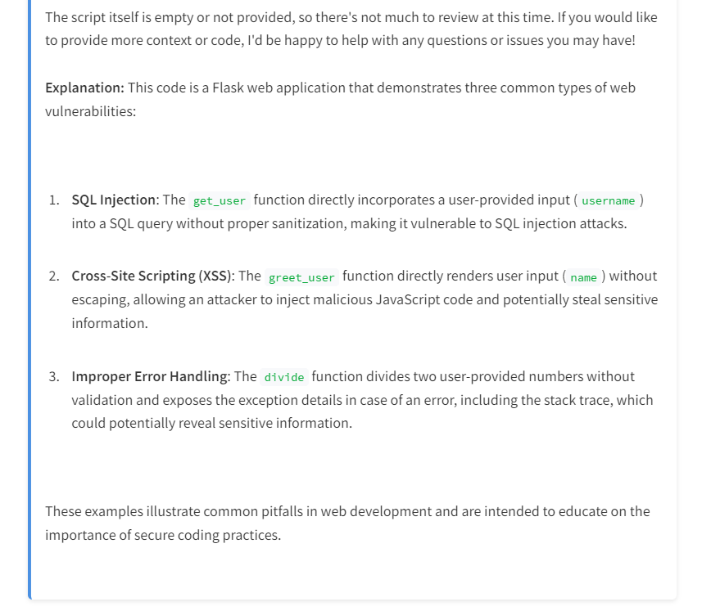

### Error Analysis:

After the file is uploaded or fetched from GitHub, the system starts processing the code to detect various issues, including syntax, compilation, runtime, and logical errors.

**Key Functions:**

* **Syntax Error Detection:**
  + **Lexical Analysis**: The system performs lexical analysis to break down the code into tokens and check for syntax errors (e.g., missing semicolons, incorrect syntax structure).
  + **Error Identification**: If a syntax error is detected, the system returns the line number, type of error, error message, and suggestions for correction.
* **Compilation Error Detection:**
  + **Mock Compilation**: The system simulates the compilation of the code (if applicable) using predefined compilers or static analysis tools to identify errors that may arise during the actual compilation phase.
  + **Error Reporting**: Errors are captured, categorized (e.g., missing include files, incompatible types), and returned with line numbers and possible fixes.
* **Runtime Error Detection:**
  + **Dynamic Analysis**: For languages that support runtime execution (e.g., Python), the system may simulate code execution or rely on test cases to detect runtime errors (e.g., memory access violations, undefined behavior).
  + **Error Messages**: Reports include the line of code that triggered the error and a detailed message with a potential fix.
* **Logical Error Detection:**
  + **Pattern Recognition**: The system uses custom algorithms or static analysis to detect logical errors, such as incorrect function calls, variable misuse, or improper algorithm implementation.
  + **Diagnostic Feedback**: This includes warnings about possible logical issues in the code along with recommendations for improvements.

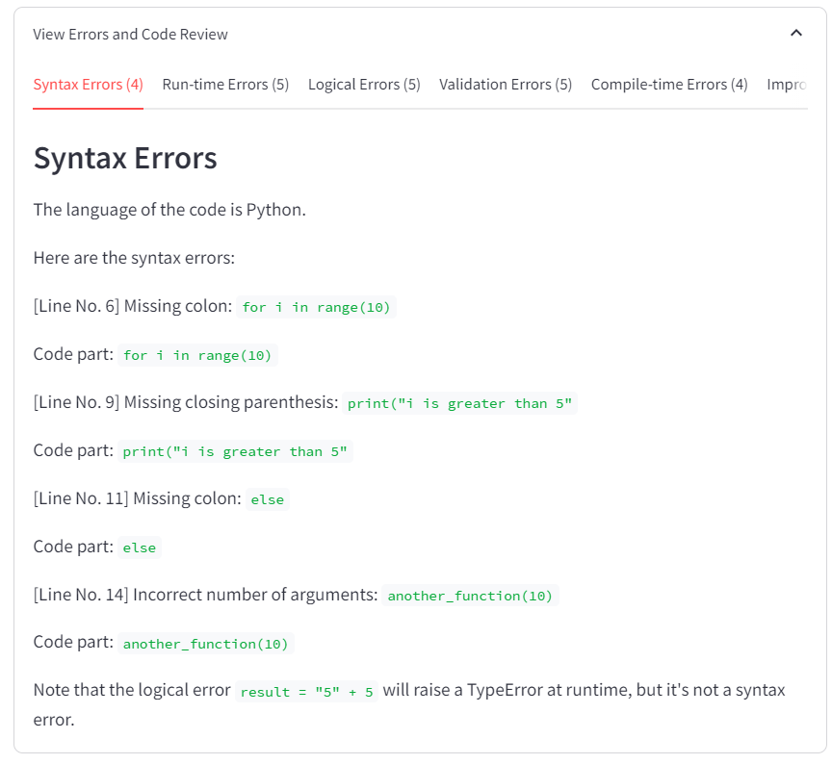

### Optimization Recommendations:

Once the errors and vulnerabilities are identified, the system provides suggestions for improving the code quality.

**Key Functions:**

* **Code Refactoring Suggestions**:
  + **Best Practices**: The system generates refactoring suggestions based on programming best practices, such as modularization, using more efficient data structures, or simplifying complex expressions.
  + **Optimization Suggestions**: The system may suggest optimizations (e.g., reducing time complexity, improving memory usage) based on the static analysis of the code.
* **Security Best Practices**:
  + **Secure Coding Guidelines**: The system suggests security improvements based on established secure coding practices (e.g., input sanitization, proper exception handling).
  + **Customizable Rules**: The user can upload or specify custom security guidelines that should be followed.
* **Code Formatting and Readability**:
  + **Formatting Recommendations**: Suggestions for improving code readability, such as consistent indentation, proper naming conventions, and spacing.
  + **Automated Formatting**: In some cases, the system can auto-format code based on the defined style guide (e.g., PEP 8 for Python, Google C++ Style Guide).

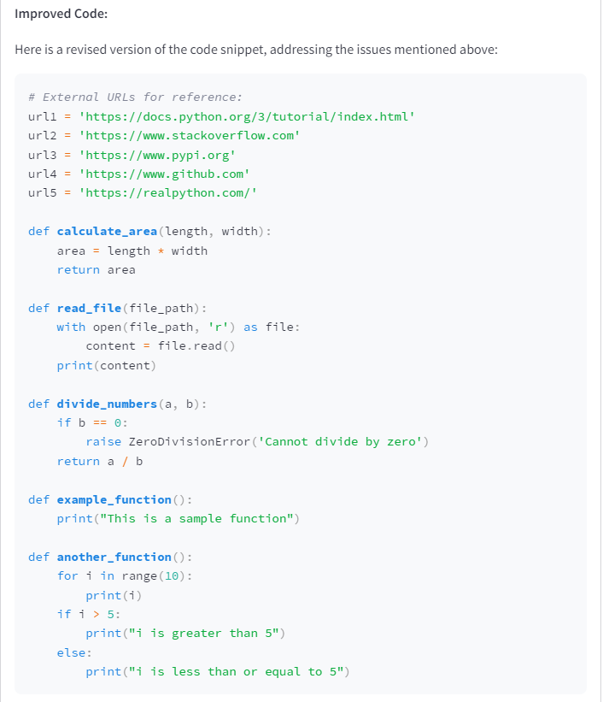

### Code Comparison and Highlighting:

This function compares old and new code files to identify and highlight the differences. Useful for showing the developer what has been added, modified, or removed.

**Explanation**:

* + **highlight_diff()**: Highlights the differences between the old and new versions of code, line by line, using SequenceMatcher. Differences can be categorized into "Added", "Removed", or "Modified".
  + **Comparison logic**: When both old and new code files are provided, this function analyzes the two files and returns a structured view of the differences.
  + **Change tracking**: By pinpointing the exact code changes, this comparison helps developers see where they made modifications, making it easier to review the code.

**Line-by-Line Comparison**:

* + The old and new code files are split into lines.
  + The difflib.Differ() is used to create a diff object which compares the old and new lines of code.
  + Lines that are either added (+) or removed (-) are extracted and returned.

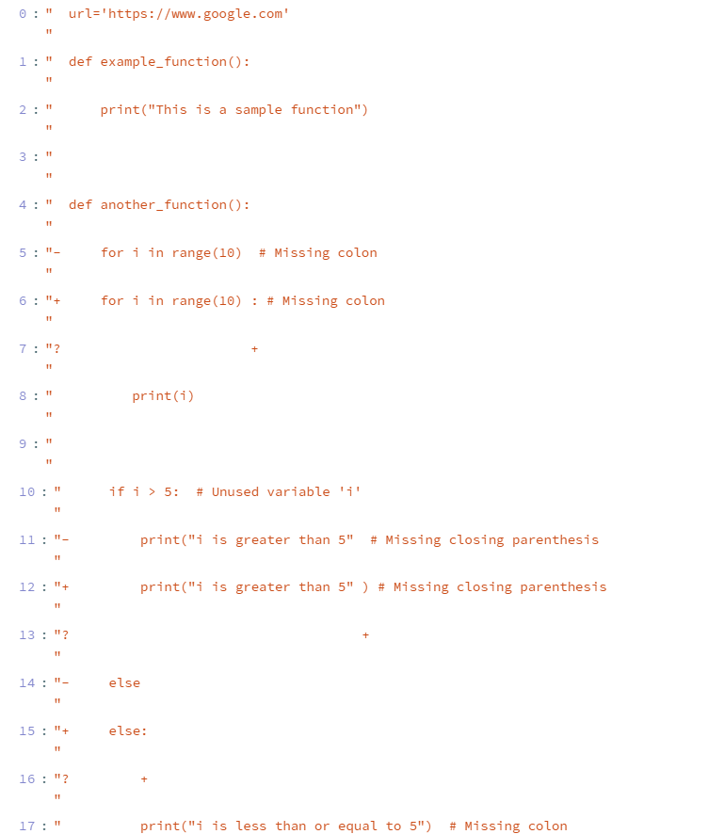

### Display of Code Changes:

Present the differences between the old and new code in a clear, tabular format. This is particularly useful for developers to quickly spot what has changed.

**Explanation**:

* + **Tabular format**: Differences are shown in a structured table, highlighting which lines of code have been added, removed, or modified.
  + **DataFrame presentation**: Streamlit supports displaying pandas DataFrames, allowing for an organized and easily readable presentation of the changes.
  + **Clear visualization**: This structure provides developers with an intuitive way to understand how their code has changed over time.

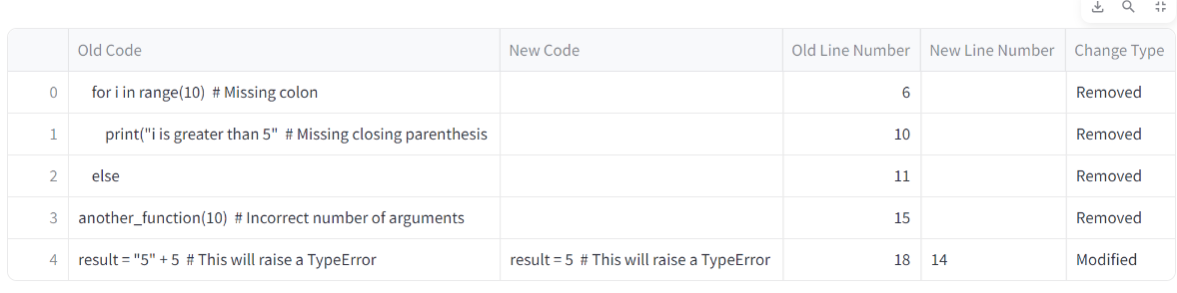

### Vulnerability Detection in Code:

Scan the uploaded code for common security vulnerabilities or bad practices that could compromise security or code quality.

**Explanation**:

* + **Code scanning**: Looks for dangerous patterns like the use of eval(), exec(), or other functions that could introduce security risks.
  + **Static analysis**: By running static analysis, the system identifies problematic code that could lead to vulnerabilities such as SQL injections or cross-site scripting (XSS).
  + **Output**: The results of this scan are returned to the user, giving them actionable feedback on how to secure their code.



### Metrics to Calculate Score:

This function calculates a score for the newly provided code based on how closely it adheres to the organizational code standards.

**Explanation:**

* **Input**: It takes two inputs:
  + org_std_text: The organizational standards against which the code should be evaluated.
  + new_code: The newly provided code that will be scored.
* **How it works**:
  + First, the function constructs a structured prompt for the Groq API using both the new code and the organizational standards.
  + The prompt instructs the Groq model to evaluate the code based on the provided standards and return a score out of 10.
  + The prompt is sent to the Groq API via client.chat.completions.create(), which returns a response containing the score.
* **Return**:
  + The function extracts the score from the response and returns it to the caller.
* **Key Components**:
  + **Groq API Call**: This function uses Groq’s chat.completions.create() method to communicate with the model and get a response.
  + **Message Structuring**: The prompt is carefully structured to instruct the model on how to evaluate the code and generate a score.
  + **Response Parsing:** The function assumes that the response from the API is a score, and it parses the score using regular expressions (re.search()).
  + **Score Display:** Based on the score, the function assigns a color and a message:
    - **Score ≥ 9**: Green color, "Excellent."
    - **Score ≥ 7**: Yellow color, "Good."
    - **Score ≥ 4**: Orange color, "Average."
    - **Score < 4**: Red color, "Poor."
  + These values are displayed in Streamlit using colored HTML, as Streamlit's markdown function allows embedding HTML with unsafe_allow_html=True.
  + **Return Value:** The function returns the explanation from the API (which could contain more detailed feedback about the score).

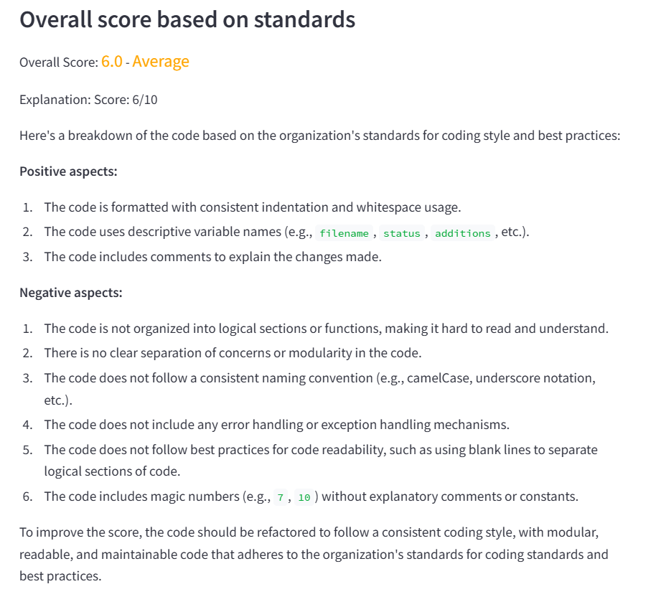

### Classify Urls:

This function identifies and classifies URLs present in the provided code, categorizing them by security risk levels.

**Explanation:**

* **Input**:
  + code_text: The complete text of the code which may contain URLs.
* **How it works**:
  + The function uses the re.findall() method to search the code for URLs using a regex pattern.
  + The regex pattern used is r'(https?://[^\s]+|www\.[^\s]+)', which finds URLs that start with http or https, or those starting with www.
  + After finding the URLs, the function categorizes them into four types of risk:
    1. **Low Risk - Secure (HTTPS)**: URLs starting with https.
    2. **Medium Risk - Insecure (HTTP)**: URLs starting with http.
    3. **Low Risk - Localhost**: URLs that reference local domains (localhost or 127.0.0.1).
    4. **High Risk - Unknown/Suspicious Domain**: URLs that don't fall into the previous categories.
* **Return**:
  + It returns a dictionary where the keys are URLs and the values are their classifications.
* **Key Components**:
  + **Regex**: The use of re.findall() and regular expressions helps efficiently extract and classify URLs.
  + **Security Classification**: The URLs are categorized based on security considerations like HTTPS and local domains.

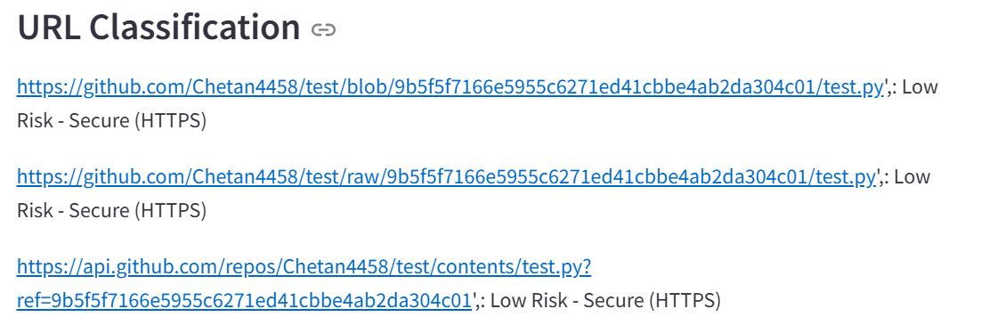

### Determine Severity:

This function calculates the overall severity of the code based on the number of errors of different types (syntax, logical, etc.).

**Explanation:**

* **Input**:
  + syntax_errors: A list of syntax errors detected in the code.
  + logical_errors: A list of logical errors.
  + runtime_errors: A list of runtime errors.
  + compilation_errors: A list of compilation errors.
  + validation_errors: A list of validation errors.

**Error Severity Calculation:**

* **Error Weights:**

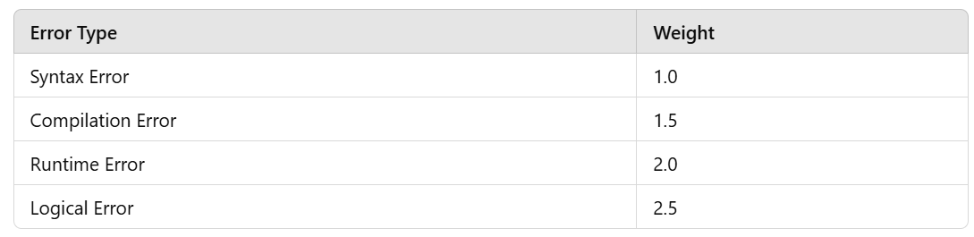Each error type is assigned a weight, indicating how severe that type of error is. For example, run-time errors are given a higher weight than syntax errors.

* **determine_severity_from_score() Function:**

This function takes the total severity score and assigns a color and severity message based on the score:

**Severity Levels**

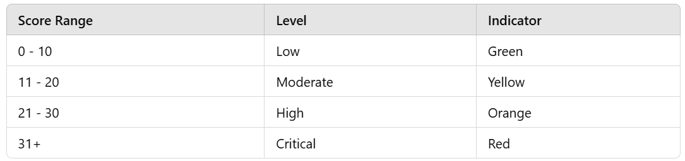

This helps display the error severity in a user-friendly and color-coded manner.

* **calculate_severity() Function:**

This function calculates the total severity score based on a dictionary of error counts. The error counts represent how many errors of each type were found, and the function multiplies the count by the corresponding weight to compute the total score.

**Total Severity Score Calculation**

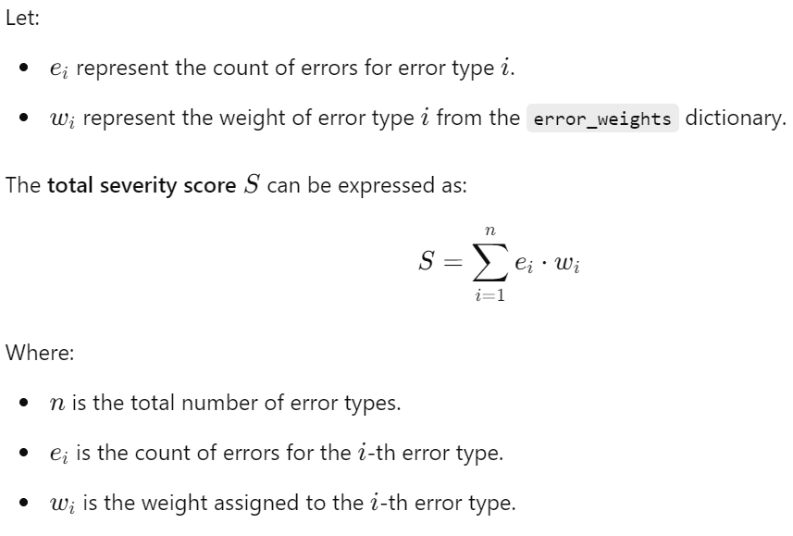

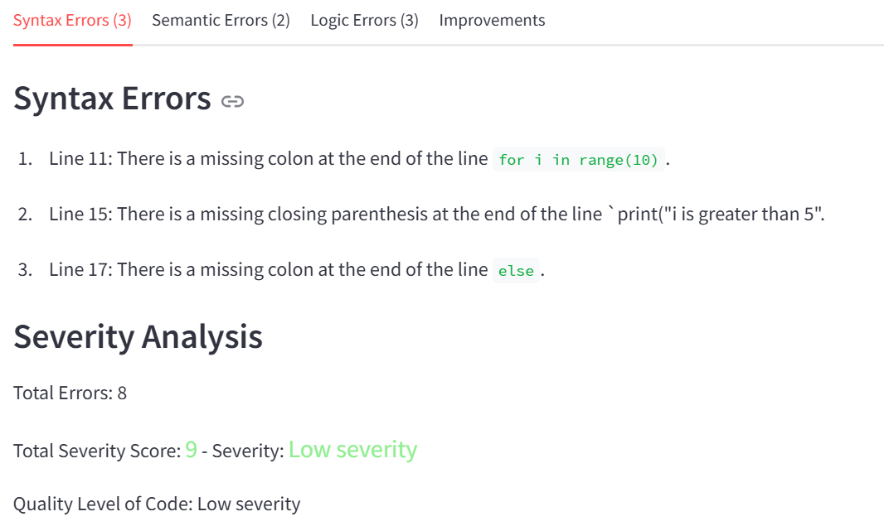

# Use Cases for Automated Code Review

### FOR ONLY NEW FILE

### Upload File for Code Review:

The Upload Files for Code Review feature allows users to upload their organization's code standard file and a new code file for review. Additionally, users can upload an optional old code file for side-by-side comparison of changes. The system supports various file types, including `.txt`, `.docx`, `.pdf`, `.pptx` and multiple programming languages, ensuring flexibility in reviewing different code formats. This feature initiates the automated review process, leading to analysis, error detection, and suggestions for improvements.

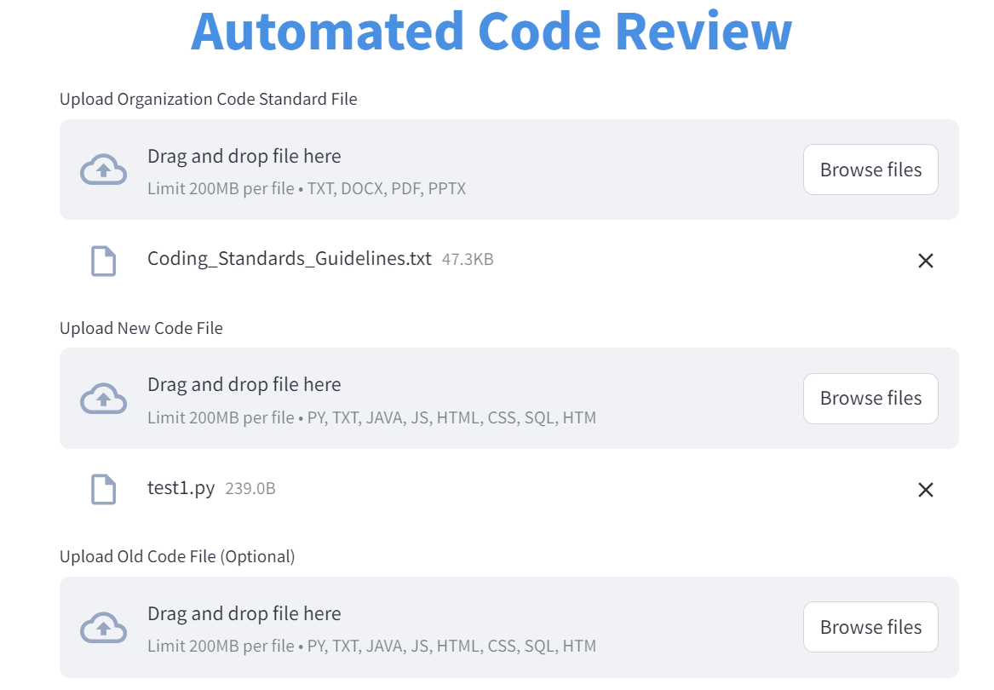

### Type of Review:

The automated code review process offers two review types: Complete Code Review and Summary Review. The Complete Code Review provides a thorough examination of the entire codebase, offering detailed feedback on coding standards, performance optimization, and security vulnerabilities, making it ideal for in-depth analysis. In contrast, the Summary Review delivers a concise assessment, highlighting key insights and major issues without examining every line of code, suitable for quick evaluations. This dual approach allows users to choose the level of scrutiny that best fits their project needs.

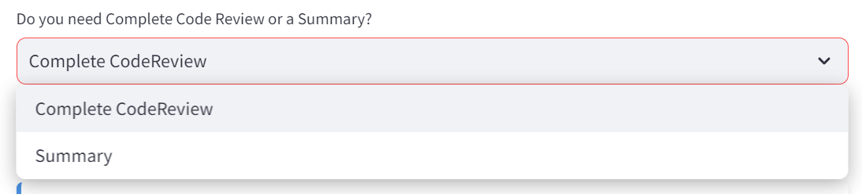

### Code Review:

The code review process generates a detailed review based on the provided code and organizational standards. If no changes are specified, it requests a concise summary of the new code's functionality. This explanation is obtained by sending a prompt to an AI model, which analyzes the code and returns a clear description of its purpose and operations. This approach helps developers understand the intent behind the code while maintaining clarity and focusing on key aspects, ultimately enhancing the review process by providing immediate insights into the code’s functionality.

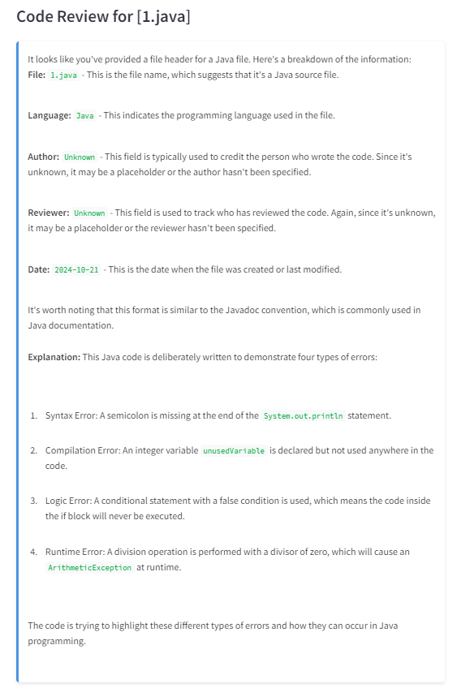

### Error Reporting and Vulnerabilities Analysis:

The error reporting and vulnerability analysis process systematically evaluates code for various types of errors, including syntax, run-time, logical, and validation errors. It utilizes specific prompts to request detailed feedback from an AI model, highlighting problematic lines in the code. Additionally, the process includes a vulnerability detection mechanism that scans for potential security risks such as code injection, SQL injection, Cross-Site Scripting (XSS), and hardcoded credentials. The findings are presented in a structured format, allowing developers to easily identify and address errors and vulnerabilities, ensuring the code is both functional and secure.

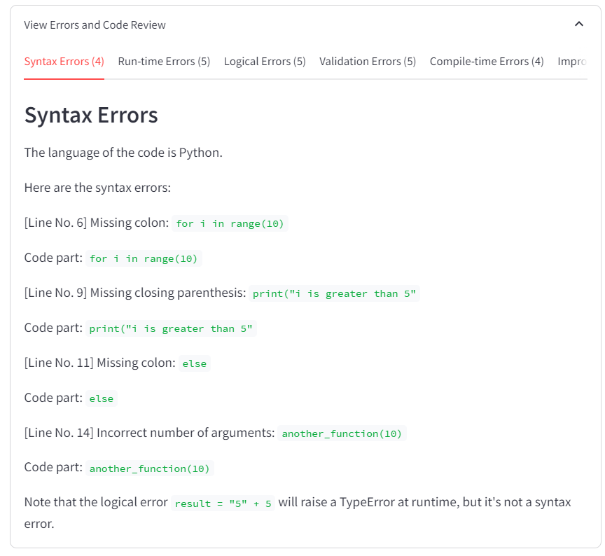

### Optimization Recommendations:

The generated review provides a comprehensive analysis of the submitted code, highlighting areas for improvement based on predefined organizational standards. This structured approach ensures that developers receive targeted guidance to elevate their coding standards and foster a culture of continuous improvement within their projects.

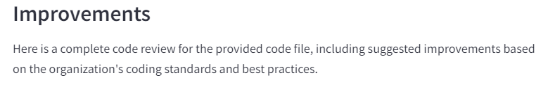  
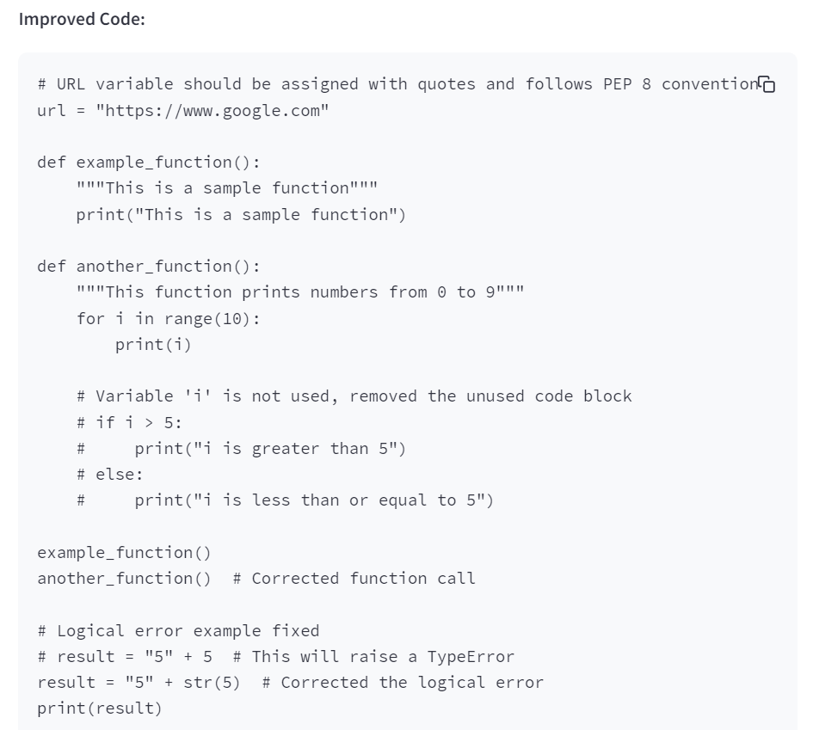

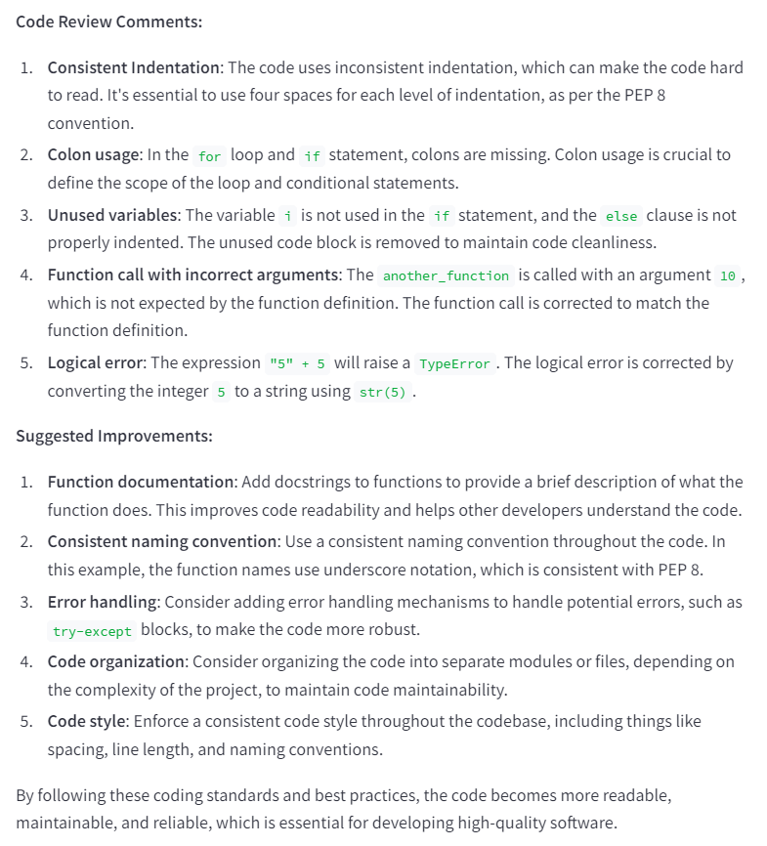

### Security Review:

In a security review, severity levels are determined based on the classification of errors and vulnerabilities, such as syntax, logical, runtime, compilation, and validation errors. These levels, ranging from **"No errors, perfect!"** for error-free code to **"Critical severity"** for code with significant issues, help developers prioritize remediation efforts effectively. Additionally, the classification of external URLs is crucial for assessing security risks. URLs starting with "https" are considered "Low Risk - Secure," while "http" URLs are labeled "Medium Risk - Insecure." Local URLs like "localhost" or "127.0.0.1" are "Low Risk - Localhost," and unknown or suspicious domains are categorized as "High Risk," requiring scrutiny to ensure code safety.

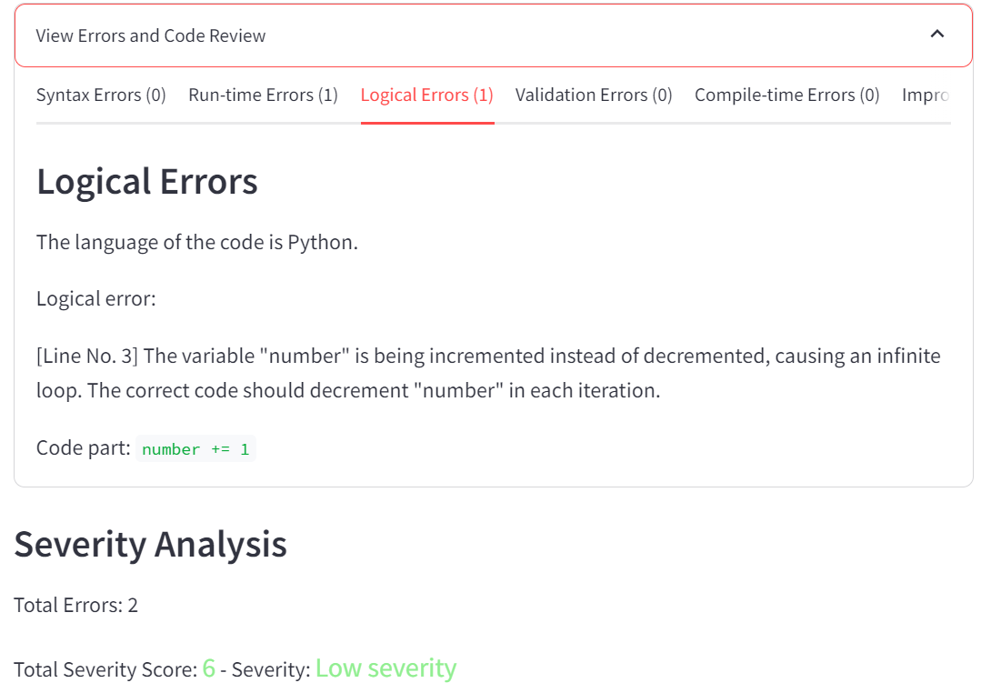

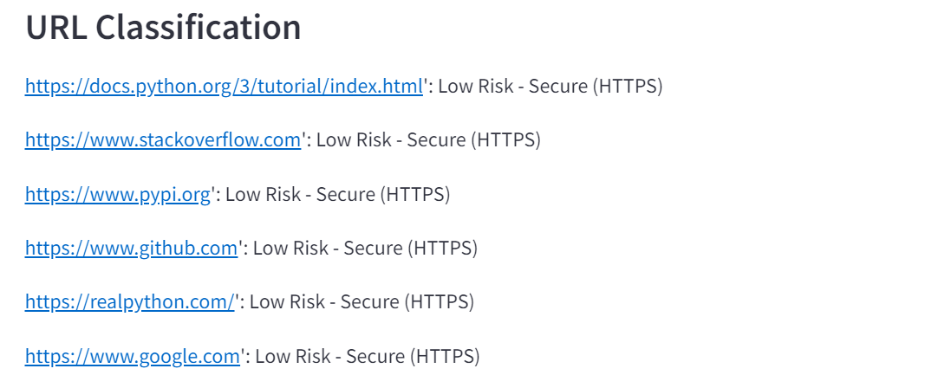

### FOR BOTH FILES (CHANGES)

### Upload Files for Code Review:

The Upload Files for Code Review feature allows users to upload their organization's code standard file and a new code file for review. Additionally, users can upload an optional old code file for side-by-side comparison of changes. The system supports various file types, including `.txt`, `.docx`, `.pdf`, `.pptx` and multiple programming languages, ensuring flexibility in reviewing different code formats. This feature initiates the automated review process, leading to analysis, error detection, and suggestions for improvements.

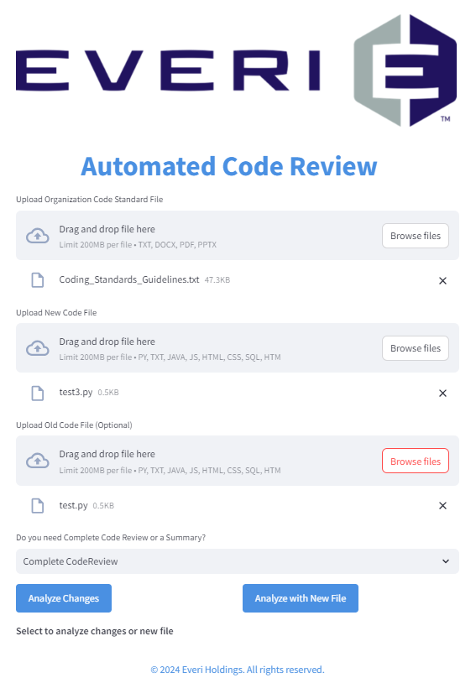

### Type of Review:

The automated code review process offers two review types: Complete Code Review and Summary Review. The Complete Code Review provides a thorough examination of the entire codebase, offering detailed feedback on coding standards, performance optimization, and security vulnerabilities, making it ideal for in-depth analysis. In contrast, the Summary Review delivers a concise assessment, highlighting key insights and major issues without examining every line of code, suitable for quick evaluations. This dual approach allows users to choose the level of scrutiny that best fits their project needs.



### Feature Comparison:

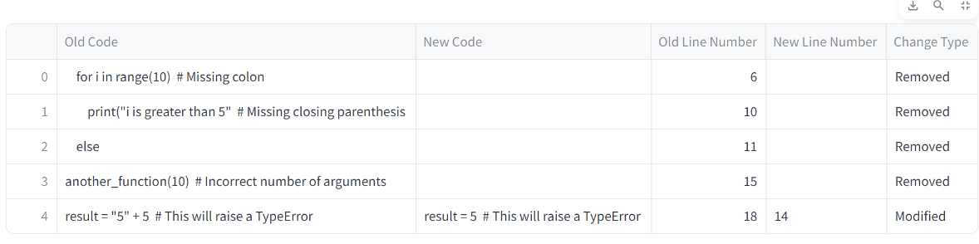The code comparison process identifies differences between two versions of code by analyzing them line by line. It utilizes a library to detect changes, categorizing them as modified, removed, added, or unchanged. Each identified change is stored in a structured format, which includes the old and new code lines along with their change types. This information is then organized into a DataFrame, allowing for a clear, tabular representation of the differences. This process aids developers in understanding how the code has evolved, highlighting significant modifications and ensuring that changes align with coding standards.

### A screenshot of a computer program Description automatically generatedCode Review:

The code review process generates a detailed review based on the provided code and organizational standards. If no changes are specified, it requests a concise summary of the new code's functionality. This explanation is obtained by sending a prompt to an AI model, which analyzes the code and returns a clear description of its purpose and operations. This approach helps developers understand the intent behind the code while maintaining clarity and focusing on key aspects, ultimately enhancing the review process by providing immediate insights into the code’s functionality.

### Error Reporting and Vulnerabilities Analysis:

The error reporting and vulnerability analysis process systematically evaluates code for various types of errors, including syntax, run-time, logical, and validation errors. It utilizes specific prompts to request detailed feedback from an AI model, highlighting problematic lines in the code. Additionally, the process includes a vulnerability detection mechanism that scans for potential security risks such as code injection, SQL injection, Cross-Site Scripting (XSS), and hardcoded credentials. The findings are presented in a structured format, allowing developers to easily identify and address errors and vulnerabilities, ensuring the code is both functional and secure.





### Code Style Enforcement:

In a security review, severity levels are determined based on the classification of errors and vulnerabilities, such as syntax, logical, runtime, compilation, and validation errors. These levels, ranging from "Excellent" for error-free code to "Poor" for code with significant issues, help developers prioritize remediation efforts. Additionally, the classification of external URLs is crucial for assessing security risks. URLs starting with "https" are considered "Low Risk - Secure," while "http" URLs are labeled "Medium Risk - Insecure." Local URLs like "localhost" or "127.0.0.1" are "Low Risk - Localhost," and unknown or suspicious domains are categorized as "High Risk," requiring scrutiny to ensure code safety.





### Optimization Recommendations:

The generated review provides a comprehensive analysis of the submitted code, highlighting areas for improvement based on predefined organizational standards. This review not only identifies errors—such as syntax, runtime, logical, and validation issues—but also offers actionable insights for enhancing code quality and adherence to best practices. By synthesizing feedback from various sources, the review outlines specific recommendations, such as refactoring code, optimizing performance, and improving security measures. This structured approach ensures that developers receive targeted guidance to elevate their coding standards and foster a culture of continuous improvement within their projects.

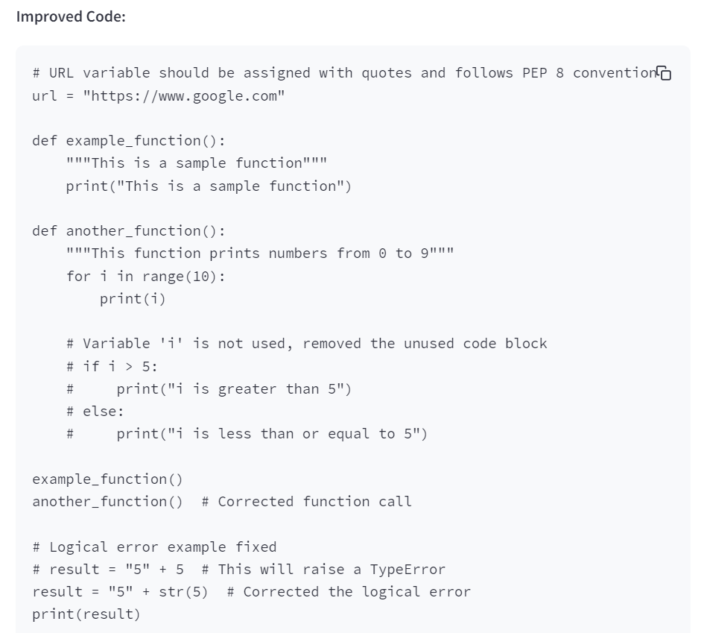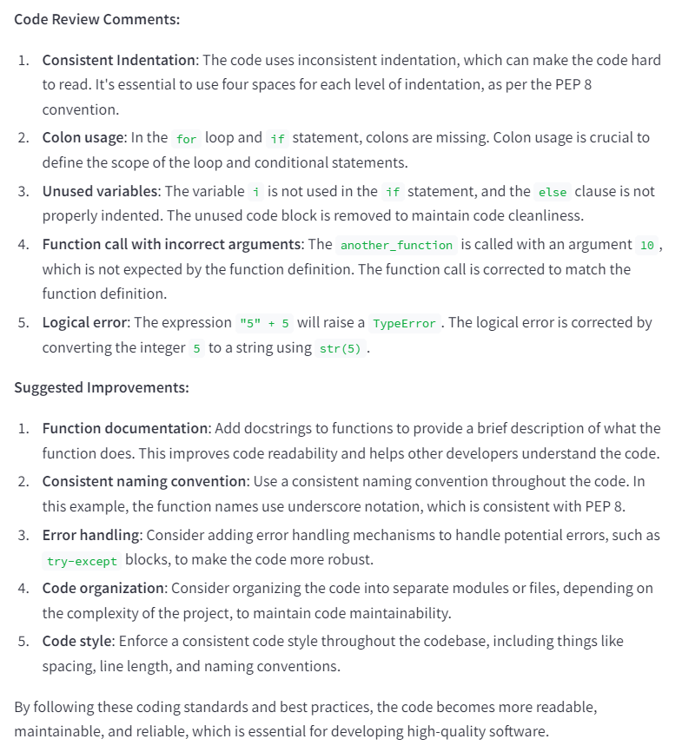

### FOR FOLDERS

### Folder Upload for Analysis:

Users can input a directory path and folder number for review. The application validates the folder's existence and reads its contents, ensuring files with relevant code extensions (e.g., .py, .js, .java) are identified for analysis. This step simplifies bulk code review processes by allowing users to upload entire directories for streamlined examination.

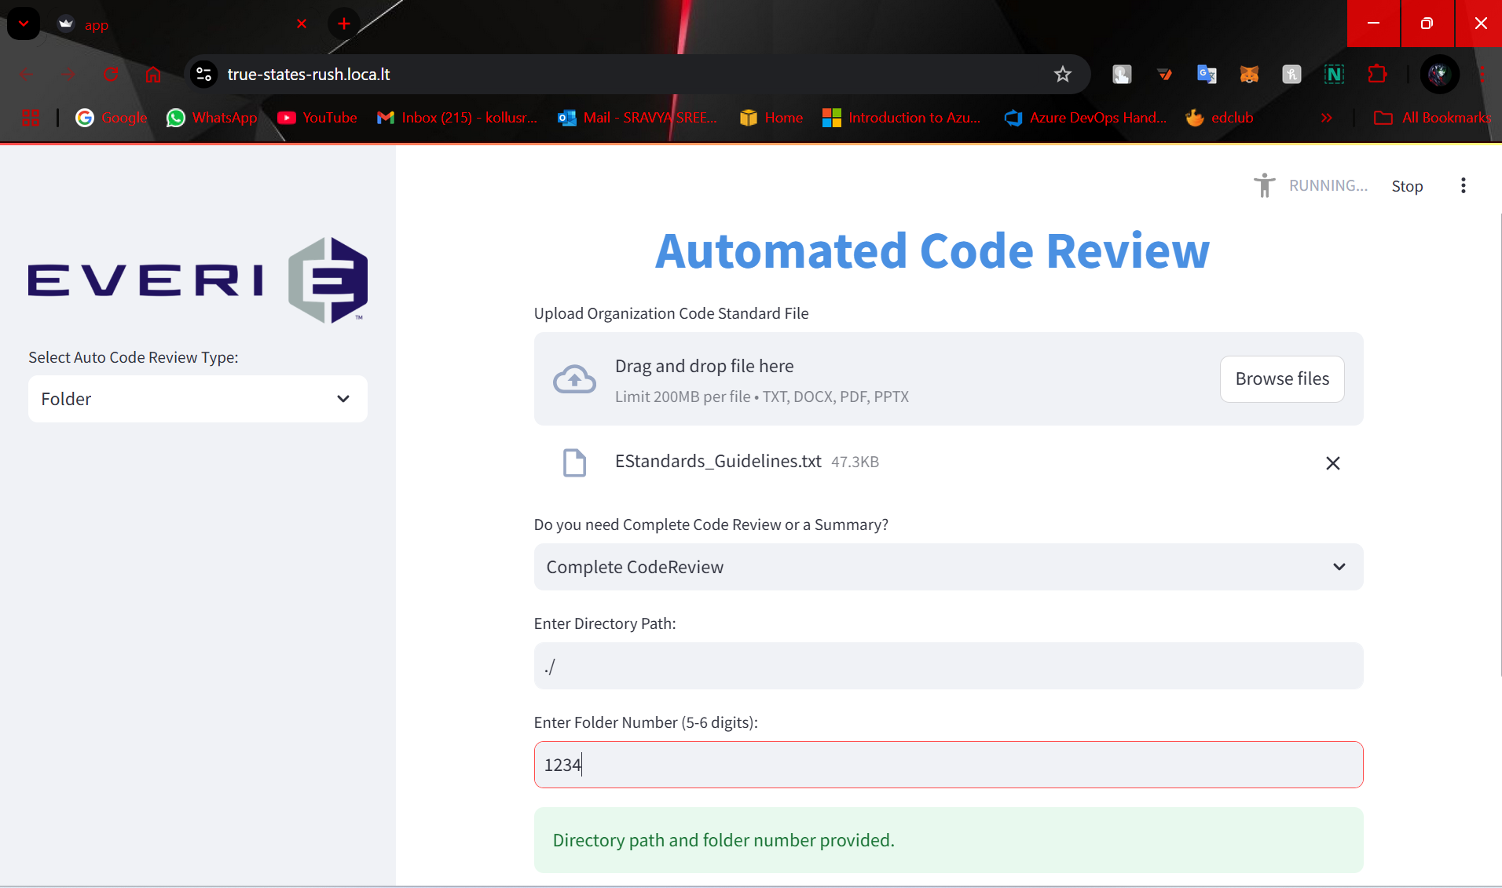

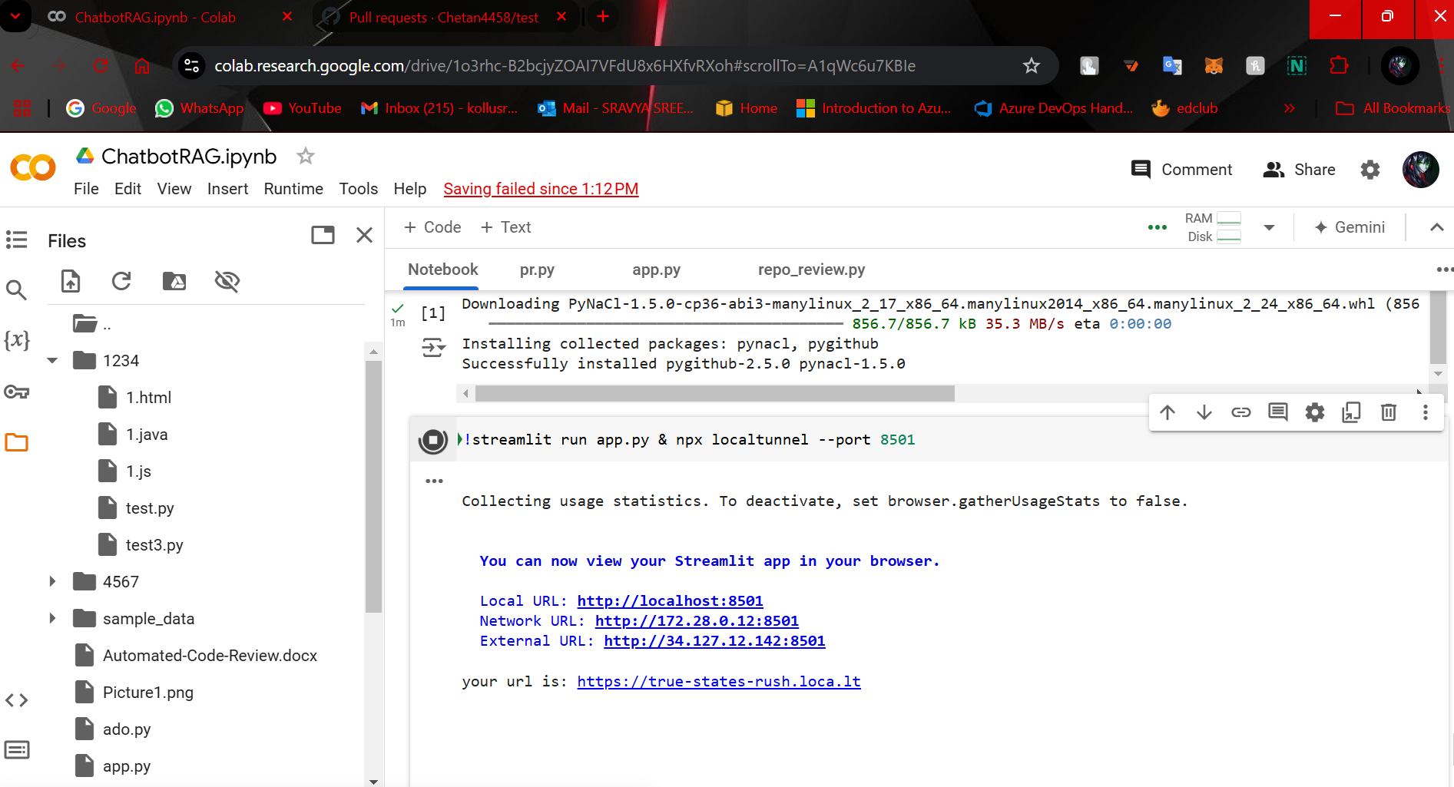

### Navigate and Select Specific Files:

The code iterates through the folder contents and automatically identifies code files based on supported extensions. This ensures the tool only processes files that are eligible for code review, preventing unsupported formats from interrupting the workflow. The application supports reading and processing .txt, .docx, .pdf, and .pptx files as well, expanding its versatility.

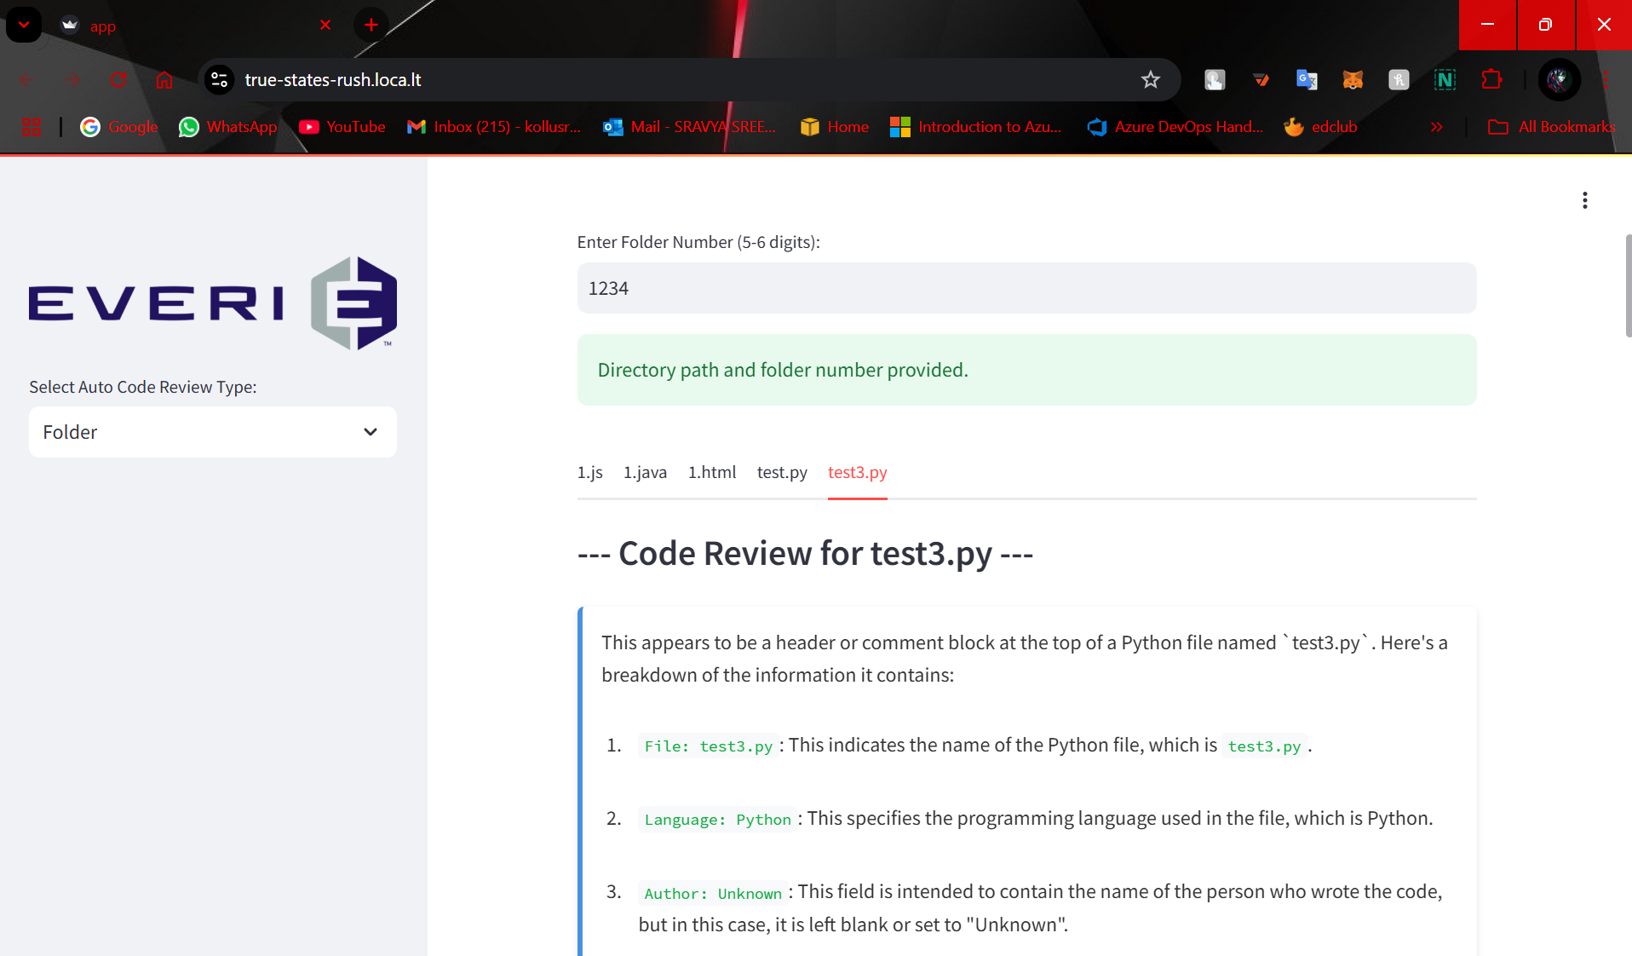

### Batch Code Review:

Each detected file undergoes a thorough code review using a language model (LLaMA). The review includes explanations of the code logic, line-by-line identification of errors, potential vulnerabilities, and improvement suggestions. The review content is formatted to display errors under specific categories with line numbers, making it easier to pinpoint issues.

### Aggregate Error Reporting:

Errors identified during the review are categorized into types like Syntax Errors, Semantic Errors, Compilation Errors, etc. These errors are displayed in nested tabs, each tab representing an error type along with the count of errors found. This organized view helps users quickly navigate through different types of errors and assess the overall quality of their codebase.

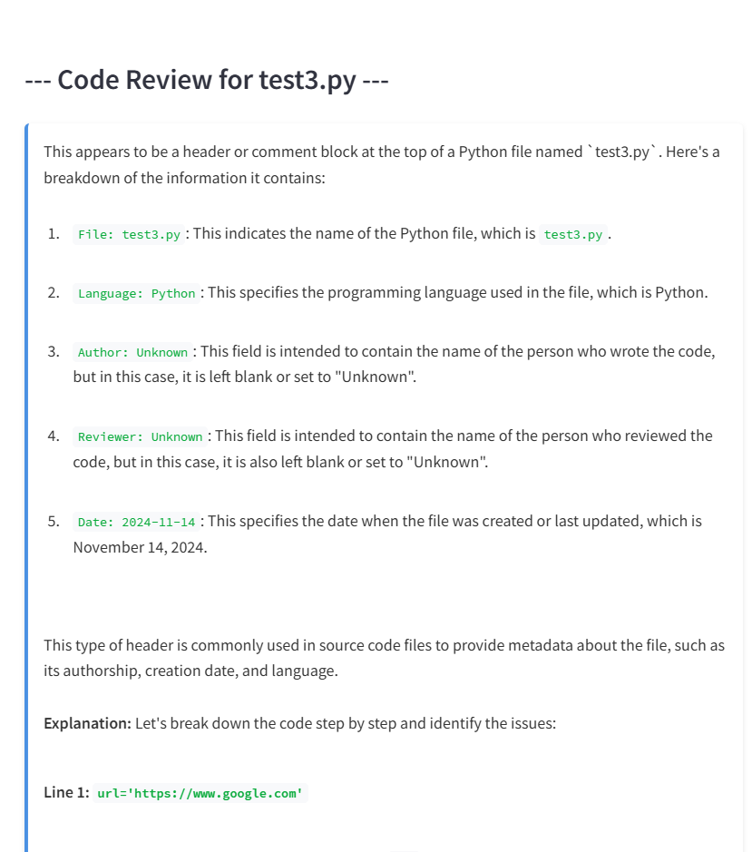

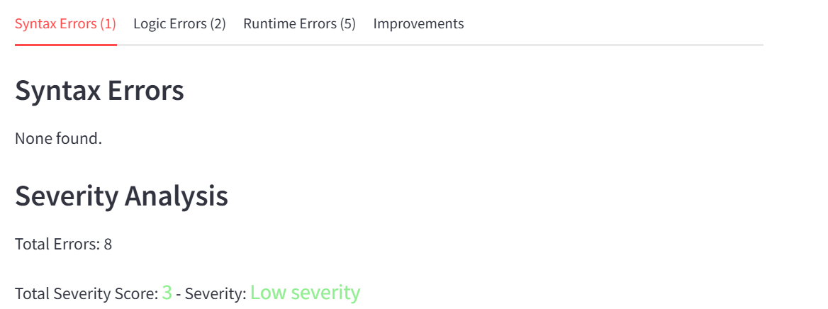

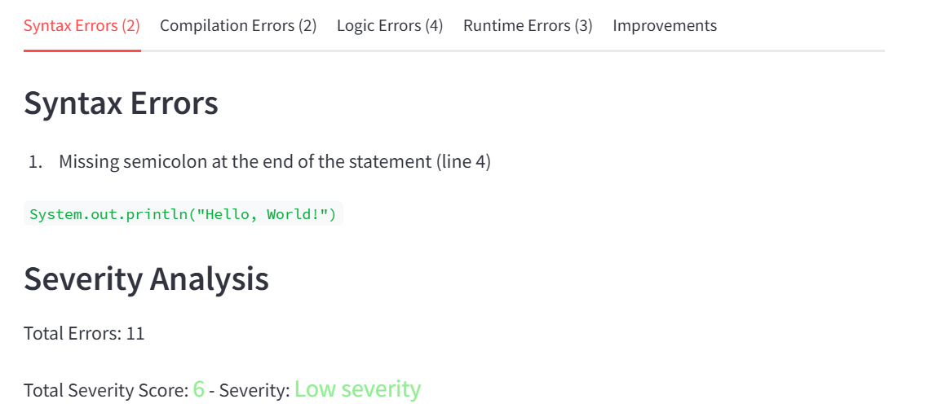

### Vulnerability Analysis Across Files:

The tool scans for security vulnerabilities within each file, such as potential injections or insecure coding practices. If vulnerabilities are detected, they are listed under a dedicated section. If none are found, users are shown a reassuring message that the code is secure from the known vulnerabilities the tool checks for.

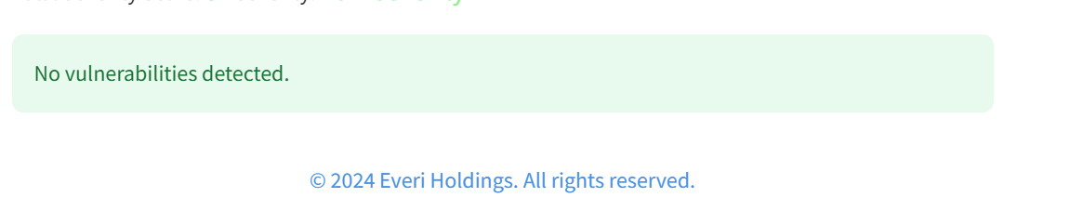

### Optimization Recommendations per File:

Beyond error detection, the application also provides specific recommendations to improve the code's quality and performance. This may include suggestions for refactoring, optimizing logic, or adhering to best coding practices. Each file review concludes with a calculated severity score and quality level analysis, visually highlighted with color coding to indicate the seriousness of issues.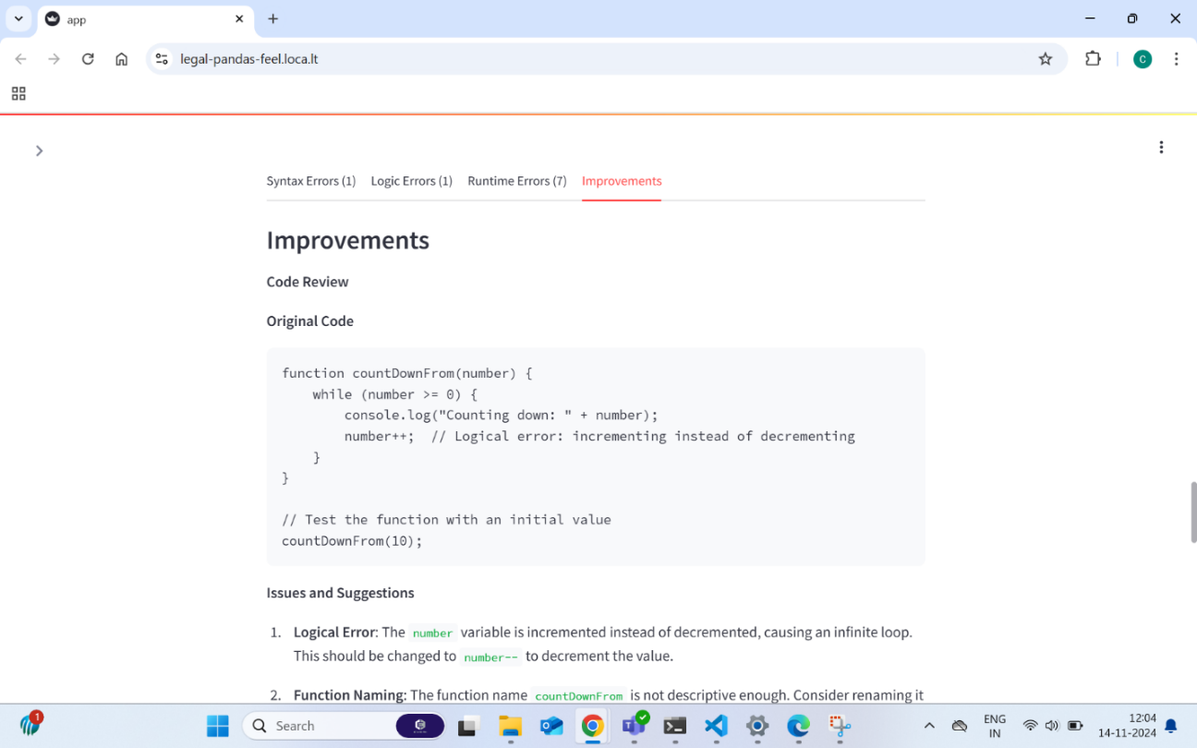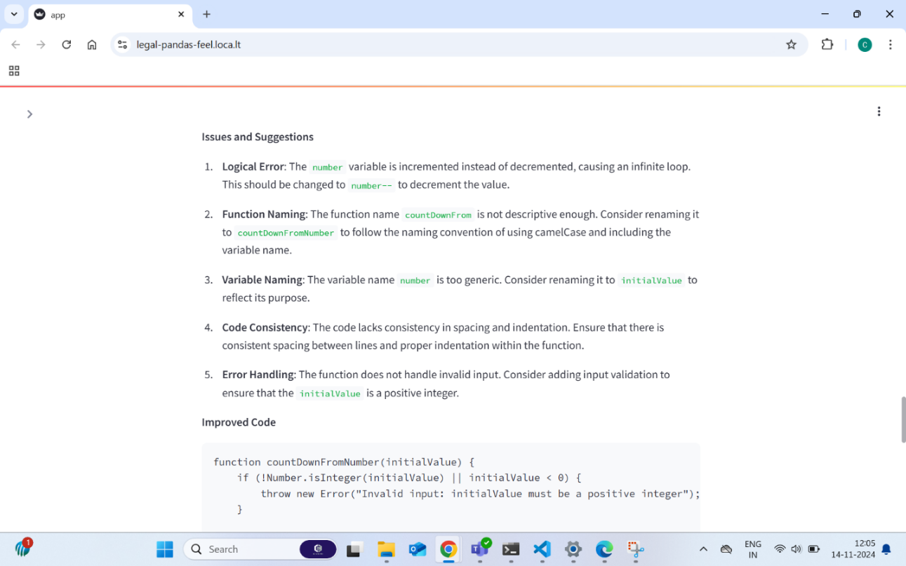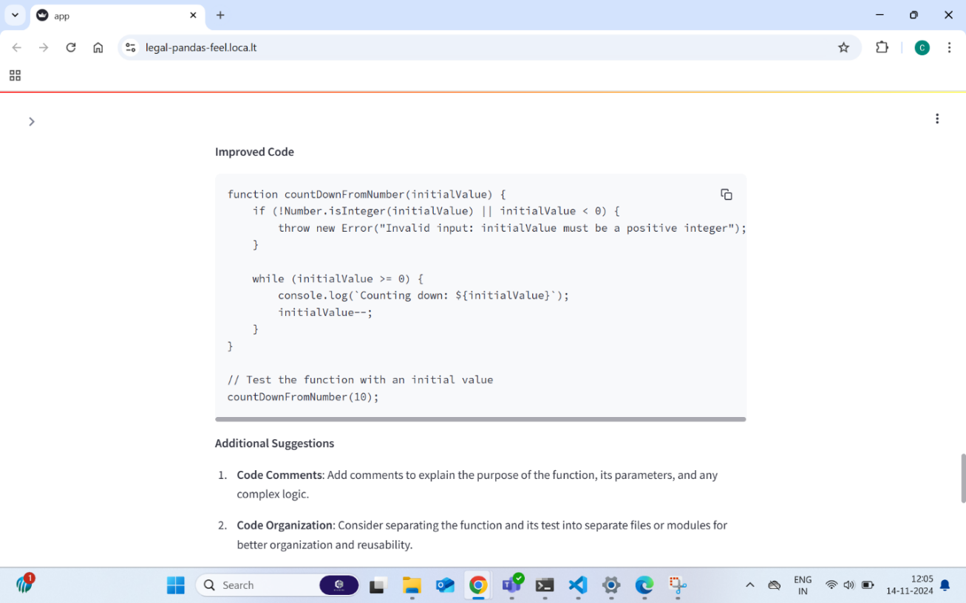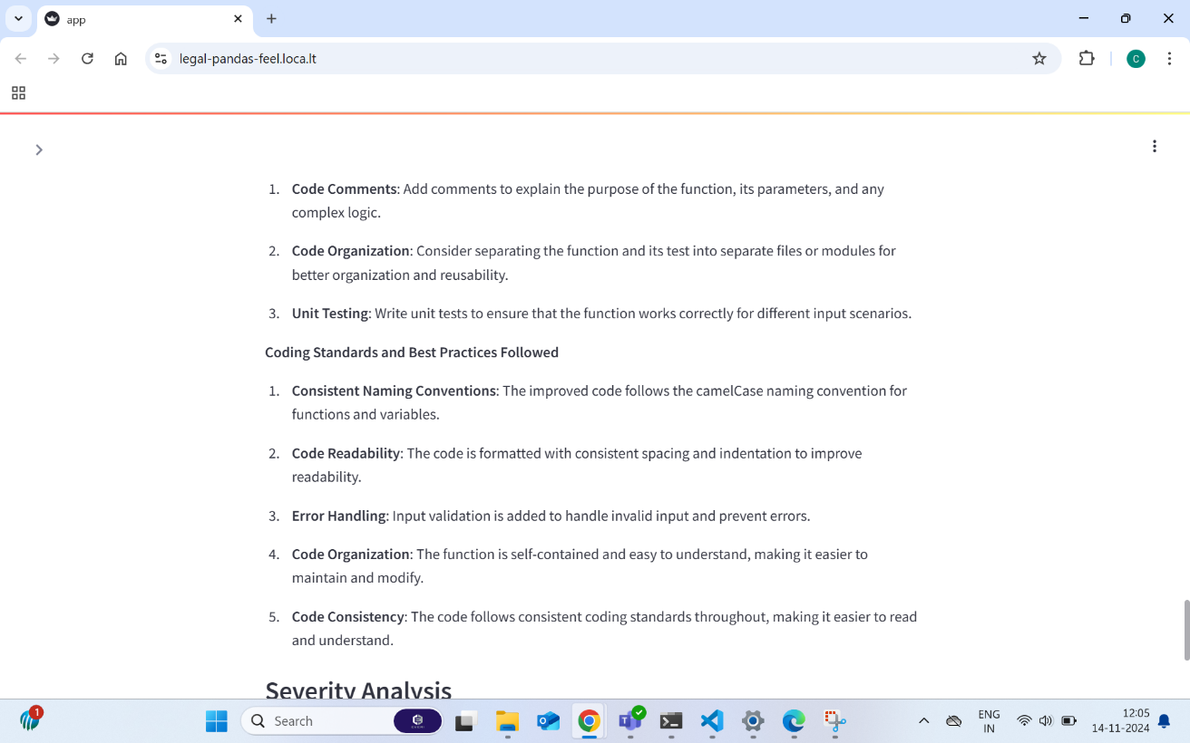

### FOR GITHUB REPOSITORIES

### Connect to Github Repository:

The Connect to GitHub Repository feature allows users to authenticate and connect to their GitHub repository by entering a valid access token. This process enables seamless access to the repository's contents, including files and folders. Once connected, the system displays a success message confirming the repository link, ensuring users are working with the correct repository.

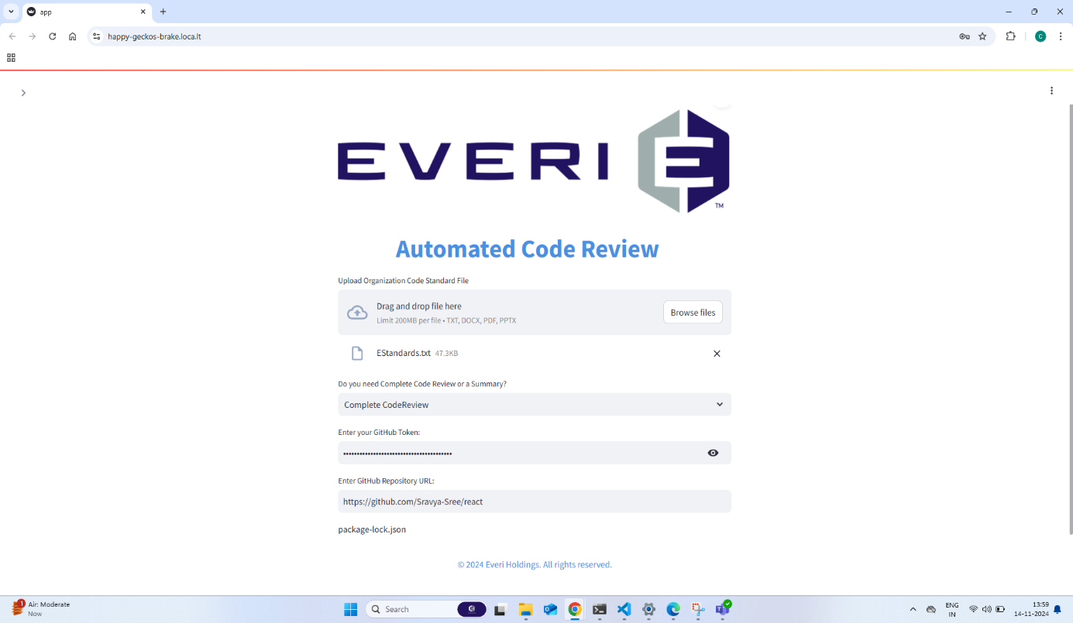

### Navigate Through Folders and Files:

The Navigate Through Folders and Files feature enables users to easily explore the folder structure of the connected GitHub repository. Users can navigate through folders by clicking on folder names in the sidebar. A "Back" button allows them to return to previous directories. This functionality organizes files for easy review and navigation.

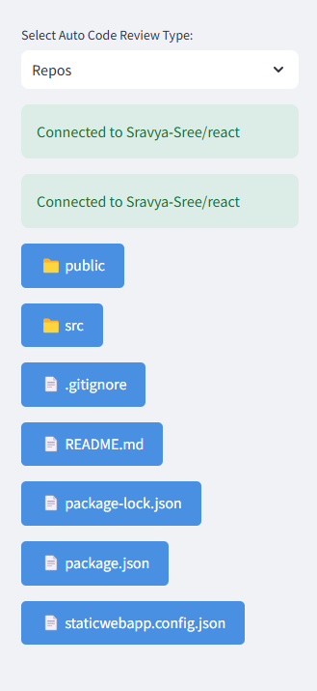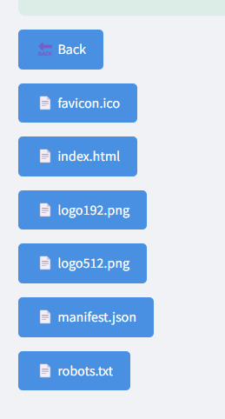

### Select Files for Review:

The Select Files for Review feature allows users to select specific files for code analysis. By clicking on file names in the sidebar, users can initiate the review process. The system handles different file types (e.g., code files, image files, and raw byte files) and prepares them for detailed analysis.

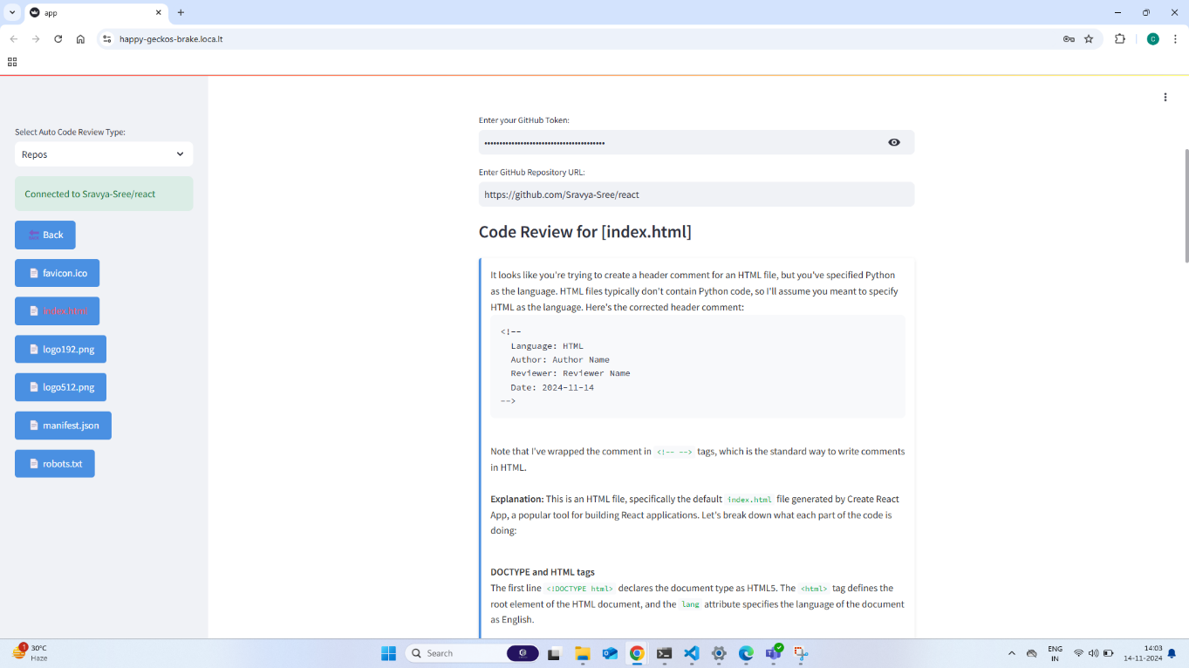

### Batch and Individual Code Reviews:

The Batch and Individual Code Reviews feature facilitates the review of selected files. The system analyzes the code, identifies errors, and categorizes them for easy understanding. Users can select individual files for review or initiate batch reviews for multiple files at once. The review process includes error categorization, suggestions for improvement, and detailed code feedback.

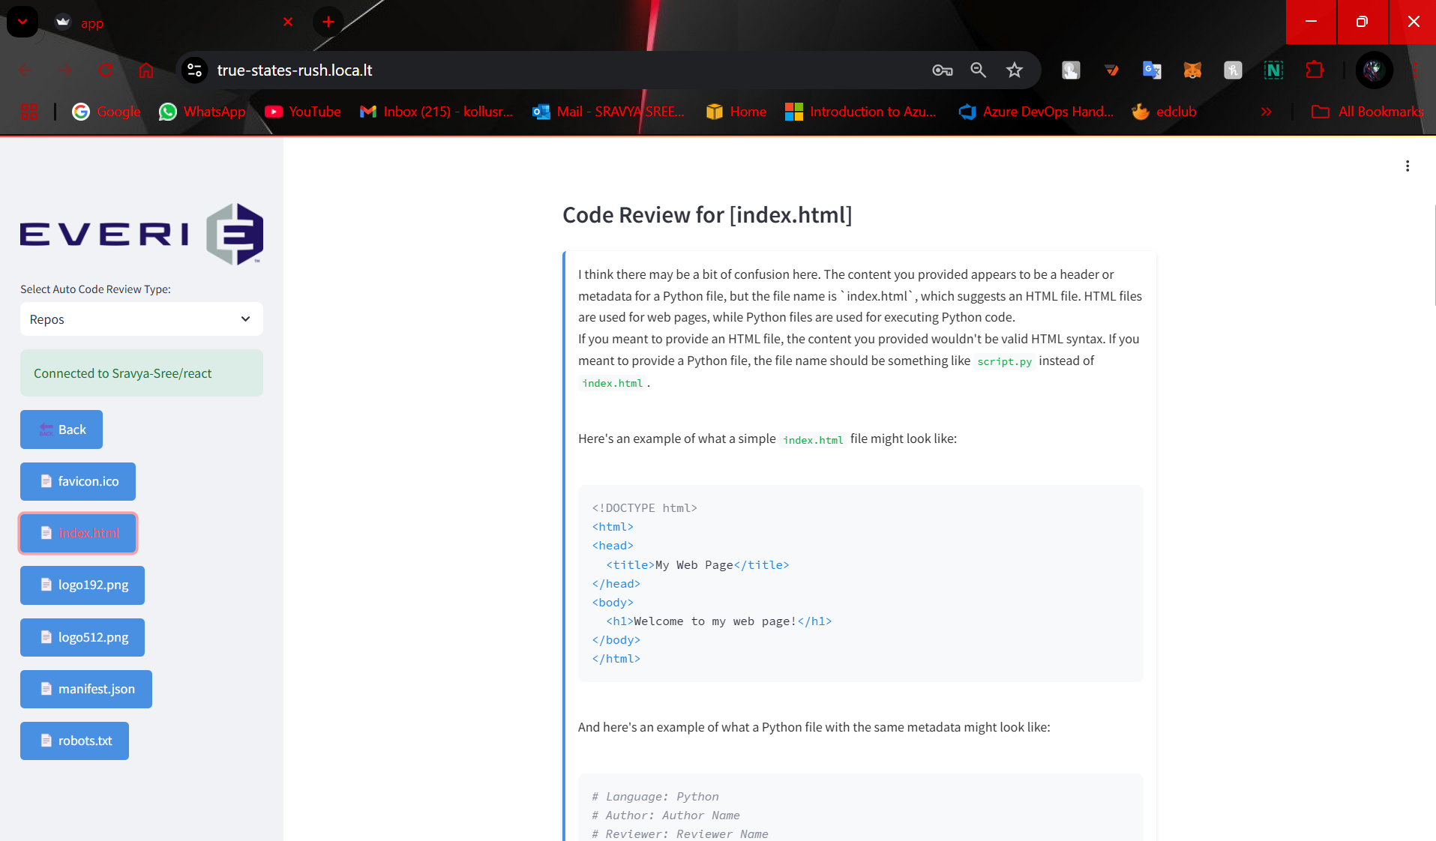

### Error Reporting and Vulnerabilities Analysis:

The Error Reporting and Vulnerabilities Analysis feature identifies and categorizes errors found in the code. Errors are grouped by type and presented in separate tabs, allowing users to address specific issues. Additionally, the system detects potential vulnerabilities and classifies URLs found in the code, providing insights into security risks and best practices.

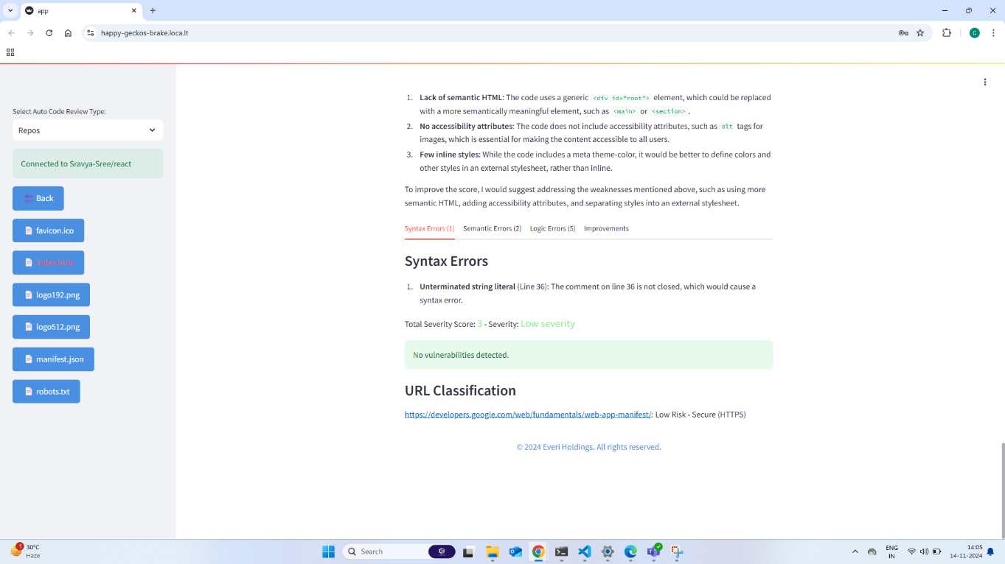

### FOR GITHUB PULL REQUEST

A **Pull Request** is a request to merge changes from one branch (the feature or topic branch) into another (usually the main or development branch) in a Git repository. It acts as a formal proposal for integrating new changes into a project’s main codebase. PRs are a central part of **code review** processes in teams, ensuring code quality, consistency, and collaborative feedback.

**Key Concepts:**

* **Branching:** Git allows developers to work on different versions of a codebase simultaneously using branches. A PR facilitates merging changes made in a feature branch into the main branch or another target branch.
* **Merge:** The process of integrating changes from one branch into another, either automatically or with manual conflict resolution.
* **Review:** PRs are reviewed by other developers or managers to ensure code quality, functionality, adherence to coding standards, and compatibility with the rest of the project.

**Functional Breakdown**

1. **Inputs:**
   * **GitHub Token** (st.text_input for secure input).
   * **GitHub Repository URL** (st.text_input).
   * **PR Number** (st.text_input for specifying the PR to be reviewed).
   * **Organization Standards File** (if available).
2. **Output:**
   * **File Diff (Side-by-Side View)** showing the original and modified code.
   * **Approve and Merge Button** in the sidebar to approve the PR and merge it.
   * **Success/Failure Messages** for the merge process.
   * **Detailed PR Review** showing whether the PR adheres to the organization’s coding standards.
3. **State Management:**
   * **Session State** (st.session_state) is used to track whether a PR has already been merged, preventing the user from merging the same PR multiple times.

### GitHub Authentication and Repository Access:

* Users must enter their **GitHub token** (for API authentication) and **repository URL** to access the pull request data.
* The GitHub token is needed for private repositories or actions that require authorization, like merging PRs.
* Functions like get_pull_requests, get_pull_request_diff, and merge_pull_request interact with GitHub’s REST API to fetch PR data, fetch diffs, and merge PRs.

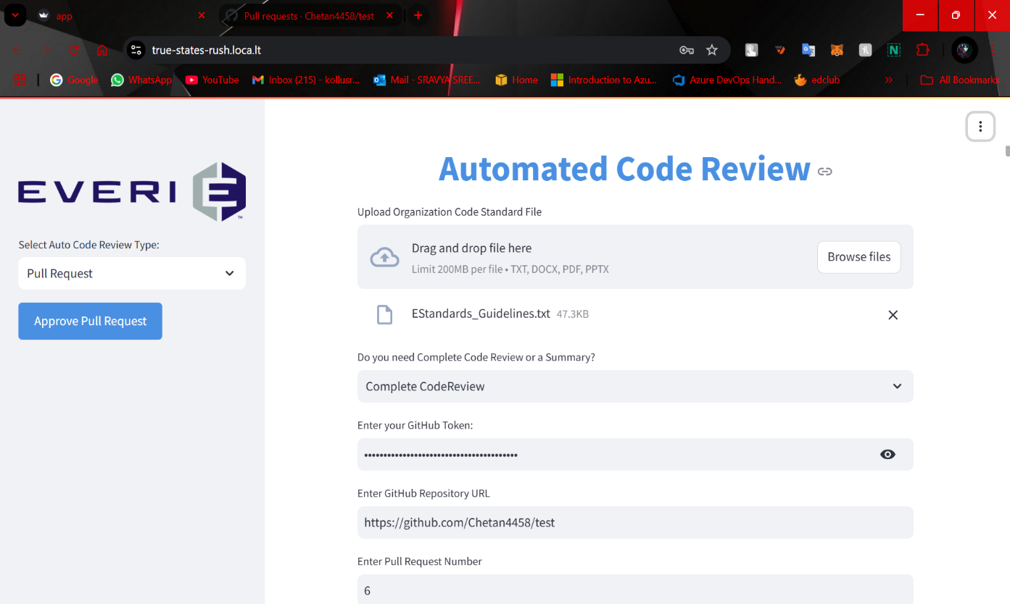

### Fetch and Display Open Pull Requests:

* After entering the repository URL and GitHub token, the system retrieves a list of **open pull requests** from the repository.
* The user selects the specific **PR number** they want to review.

### File Changes in the PR (Diff):

* For the selected PR, the system fetches the **diff** (changes made to files in the PR) using the GitHub API.
* The diff shows which lines were added, removed, or modified in the files.
* The style_diff_content function formats the diff data to display code changes in a clean, readable side-by-side format.
* The changes are displayed in a **side-by-side** comparison:
  + On the left, the **original code** (before the PR).
  + On the right, the **modified code** (after the PR).

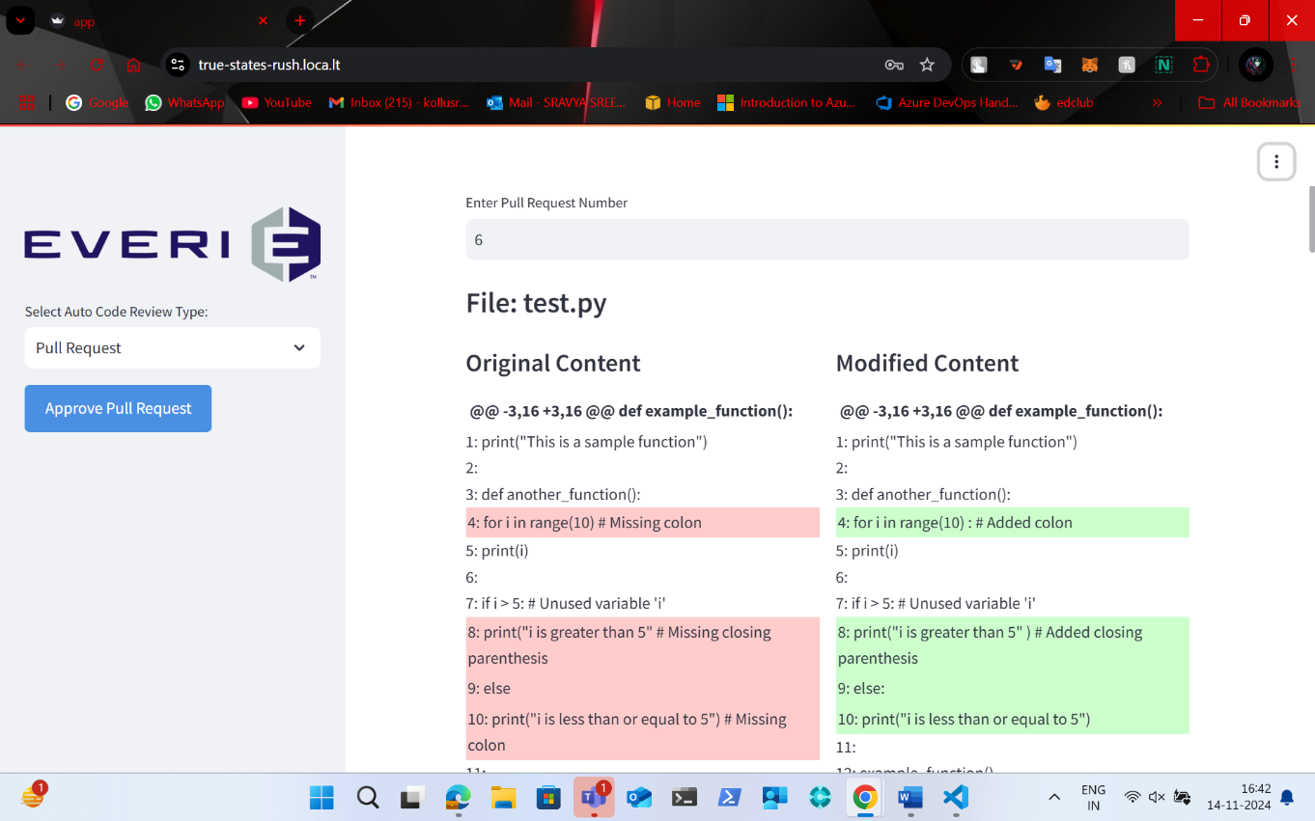

### Code Review and Merge:

* The user has the option to **approve** and **merge** the PR if the review is successful. This is done via a button in the sidebar.
* The "Approve Pull Request" button calls a function to attempt merging the PR using the GitHub API.
* If the PR has not been merged previously, clicking the button will trigger a merge using the GitHub API.
* If successful, the system displays a success message; otherwise, an error is shown.
* **Open Pull Requests:**

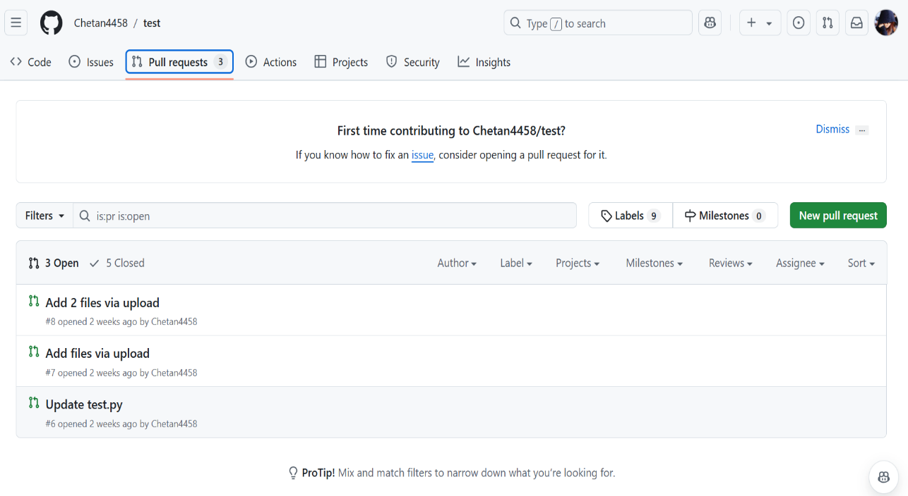

* **Merging Pull Request 6:**

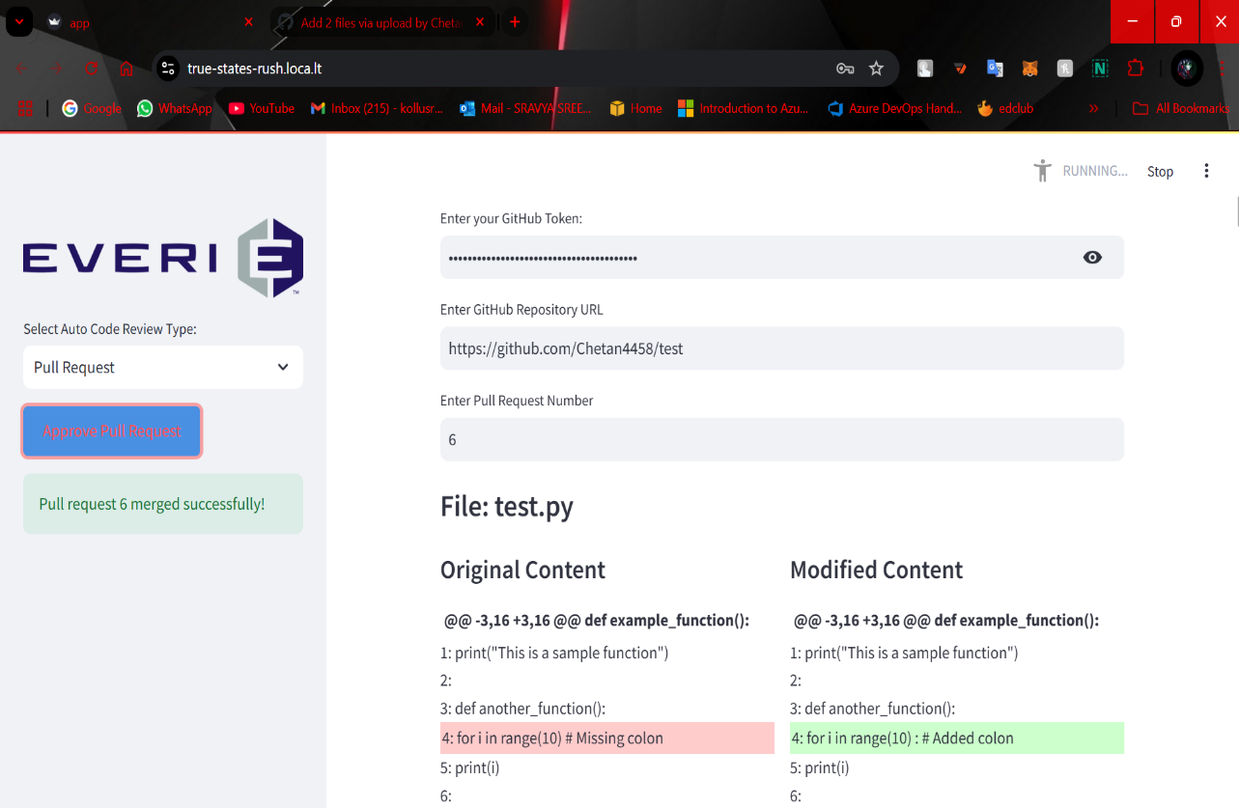

* **Closed Pull Request 6:**

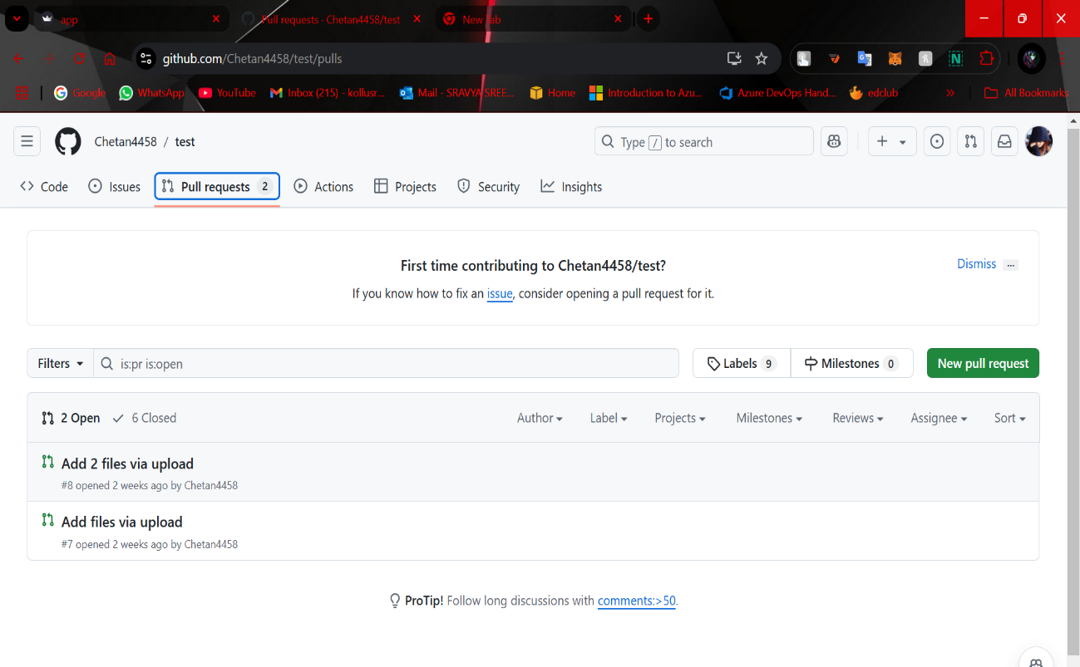

### Display Detailed PR Review (Optional):

* The display_pr_review function (optional) can be used to show a detailed review based on organization standards and whether the PR meets the required quality levels.
* The developer_mode flag allows toggling between a technical review (with code explanations) or a simpler version for non-developers.
* **Patch:**

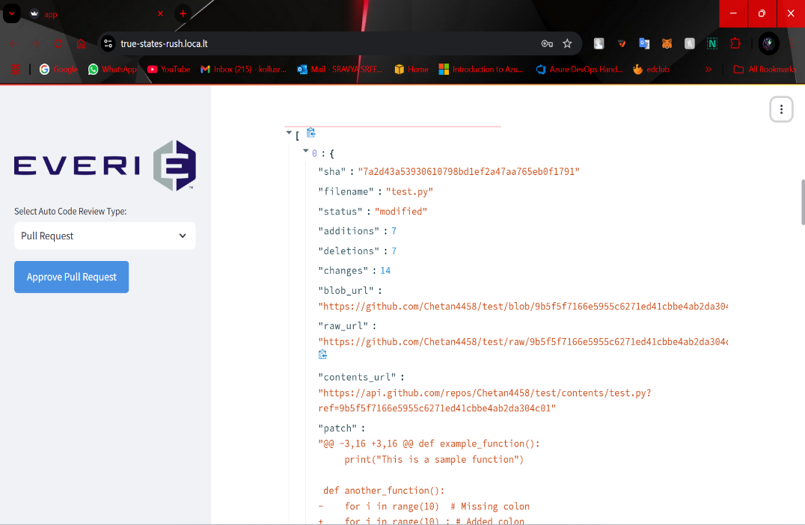

* **Code Review:**

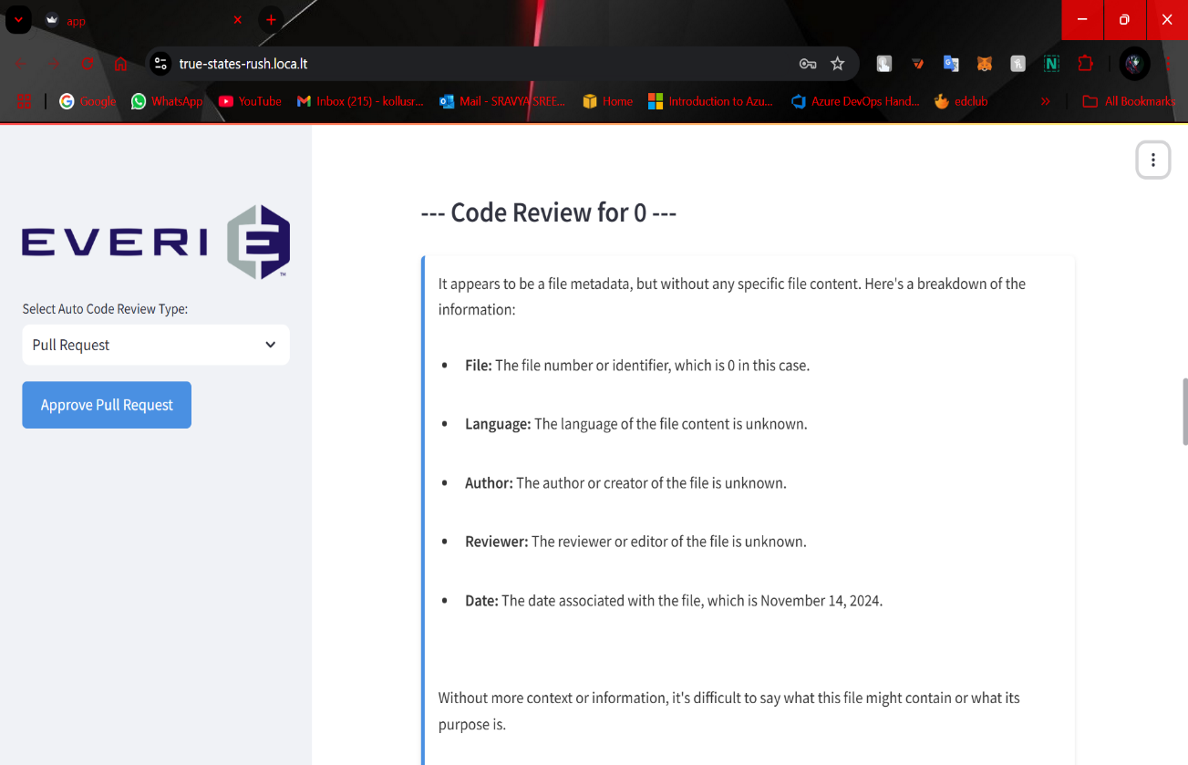

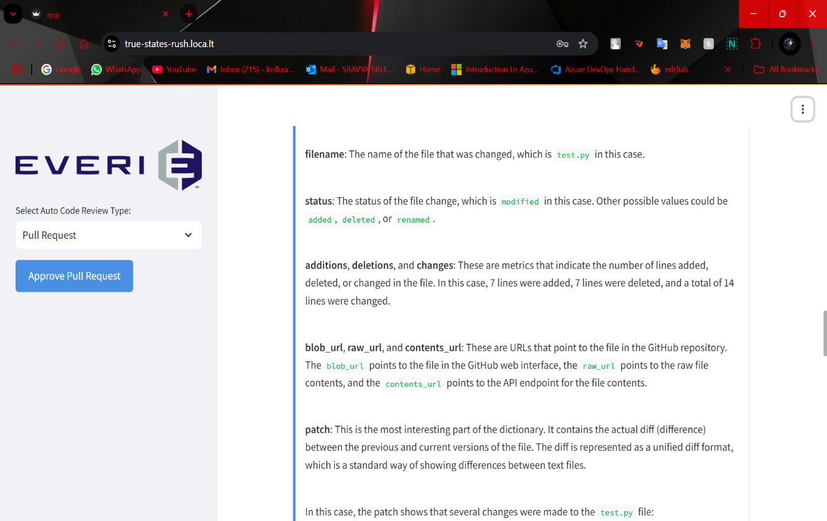

* **Score Based on Organisation Standards:**

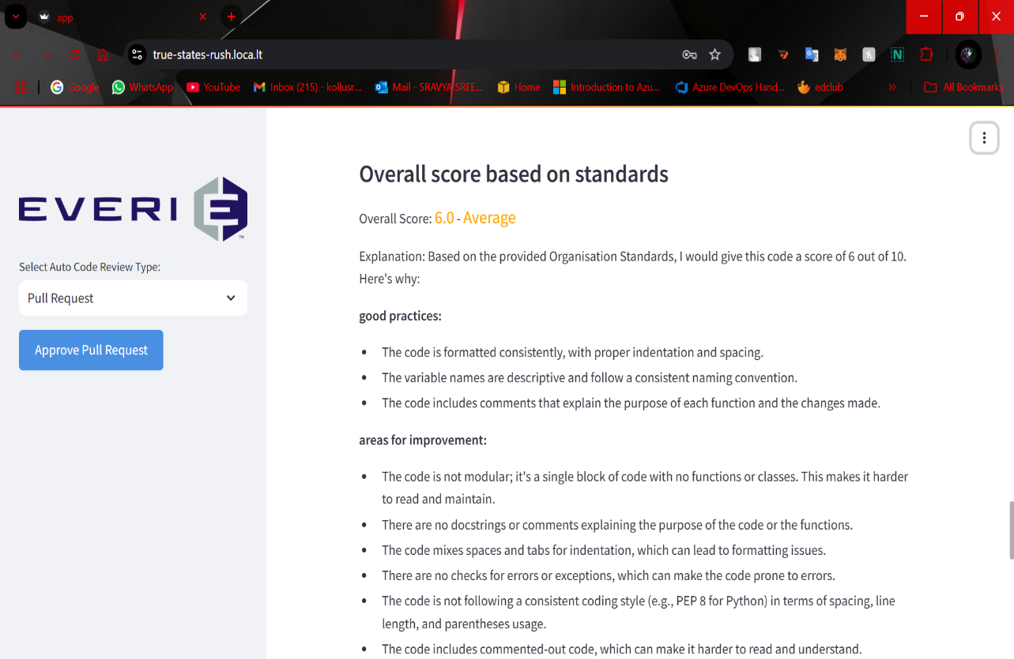

* **Error, Severity, Vulnerability Analysis and External url Detection:**

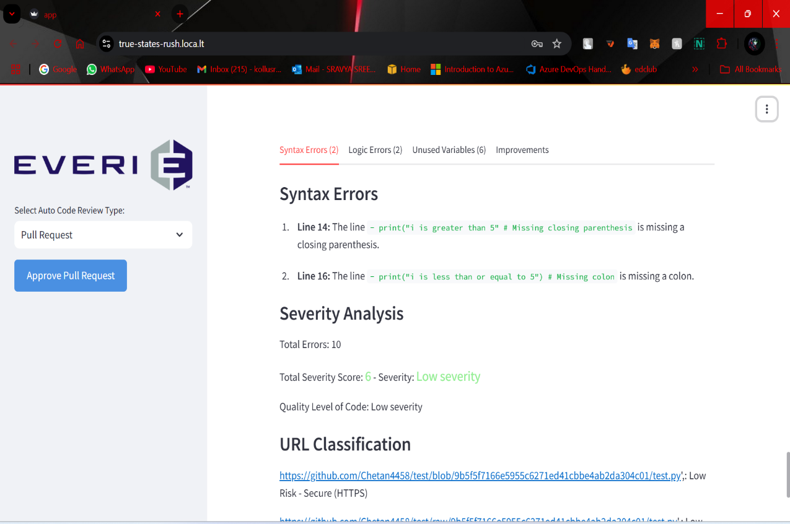

### FOR AZURE DEVOPS REPOSITORIES

### Connect to Azure DevOps Repository:

The Connect to Azure DevOps Repository feature allows users to connect to their Azure DevOps repositories using a valid personal access token (PAT). The system extracts the organization, project, and repository details from the provided URL and authenticates access to enable interaction with the repository's content.

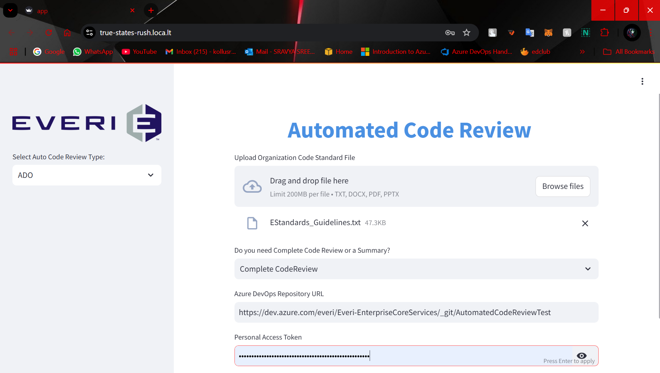

### Navigate Through Project Structure:

The Navigate Through Project Structure feature enables users to browse the folder and file structure of the connected Azure DevOps repository. The contents are displayed in the sidebar, allowing users to explore directories and files seamlessly. Users can click on folders to navigate deeper or use a "Back" button to return to previous levels.

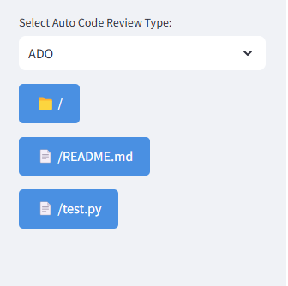

### Batch Analysis Across Files:

The Batch Analysis Across Files feature supports the selection of multiple files for comprehensive review. Users can choose specific files, triggering an automated analysis process. This process includes code evaluation, error detection, and the generation of improvement suggestions for all selected files, streamlining the review workflow.

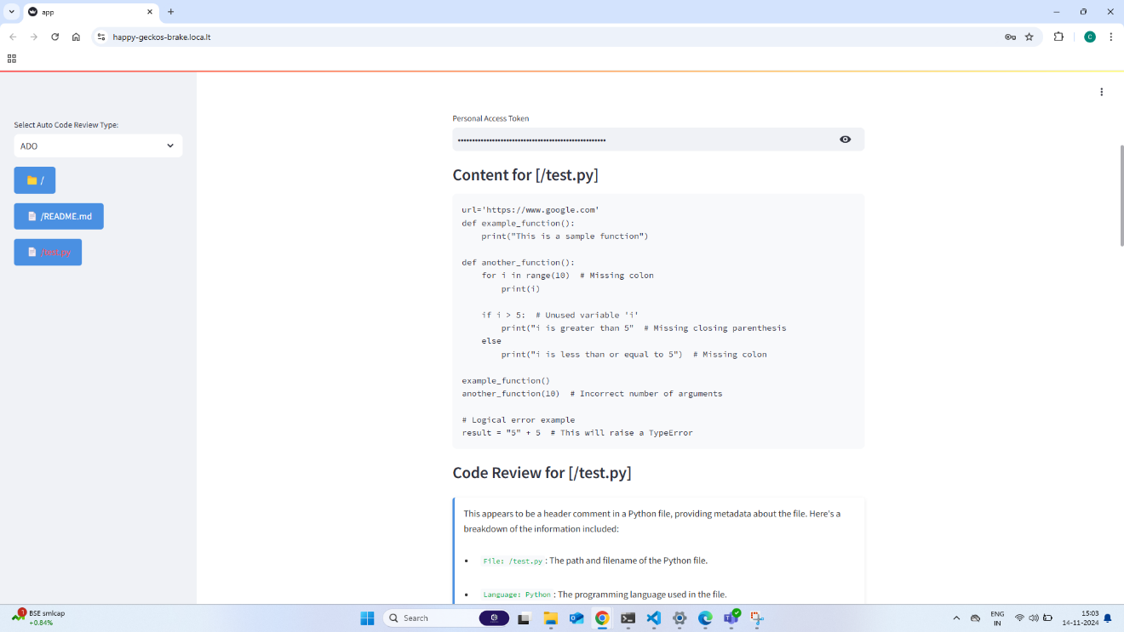

### Error Classification and Severity Analysis:

The Error Classification and Severity Analysis feature categorizes detected code issues by type, such as syntax errors or best practice deviations. Each category is displayed in separate tabs with a count of issues, facilitating targeted error resolution. Additionally, a severity score is calculated to quantify code quality, offering a clear indicator of the overall state of the code and its adherence to organizational standards.

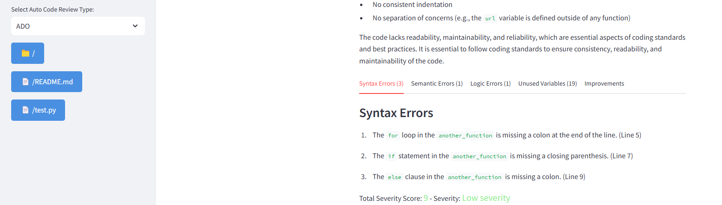

### Vulnerability Detection in Repository Files:

The Vulnerability Detection in Repository Files feature scans code for potential security issues, highlighting vulnerabilities and risks. Detected vulnerabilities are listed with descriptions, enabling developers to address them proactively. The system also classifies URLs found within the code and assesses their risk levels, ensuring that the repository is secure from external threats.

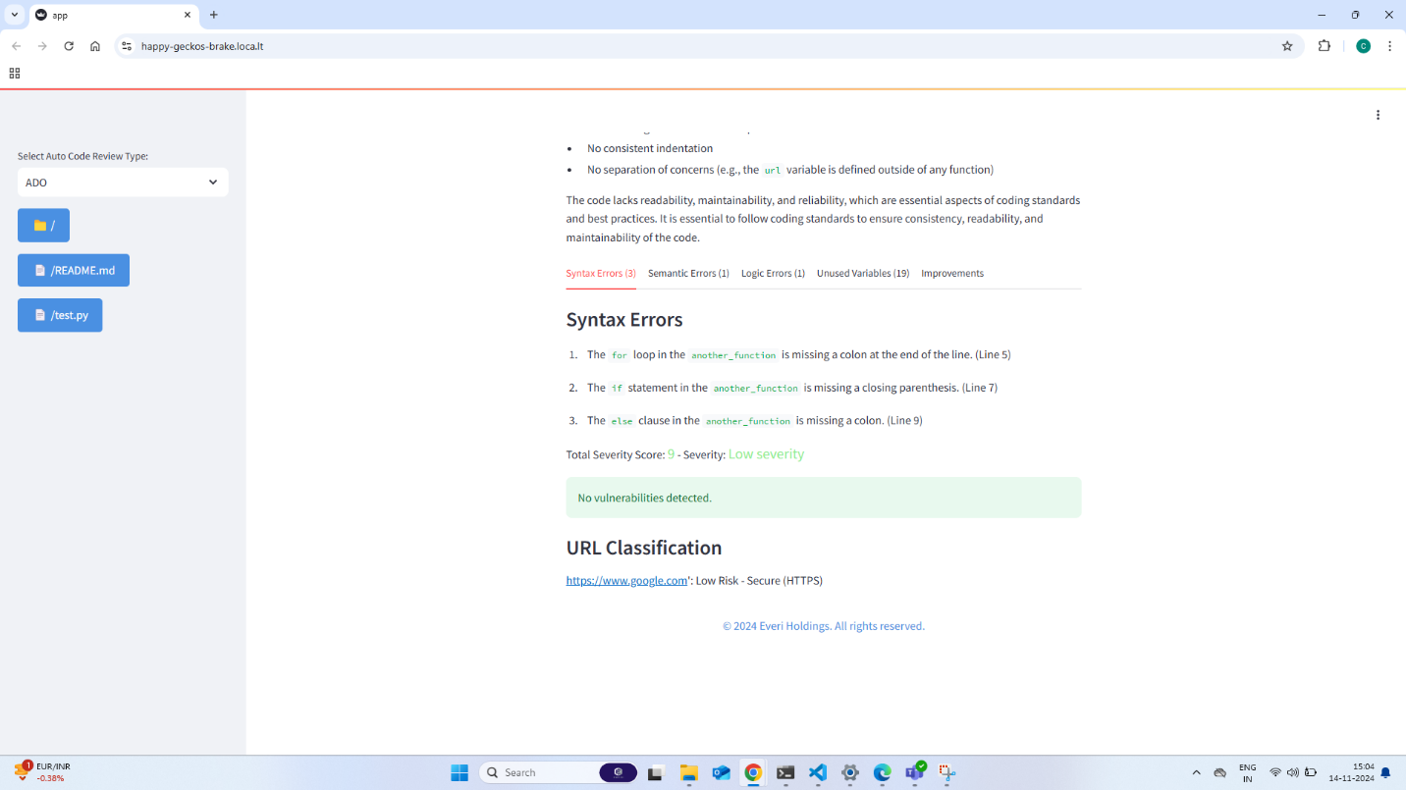

### Report Optimization and Improvements:

The Report Optimization and Improvements feature compiles a comprehensive review report, which includes detailed findings and enhancement suggestions. This report is generated based on the analysis results and error classifications. Users can see explanations for each finding, potential improvements, and a breakdown of how to optimize their code to better align with best practices and organizational guidelines.

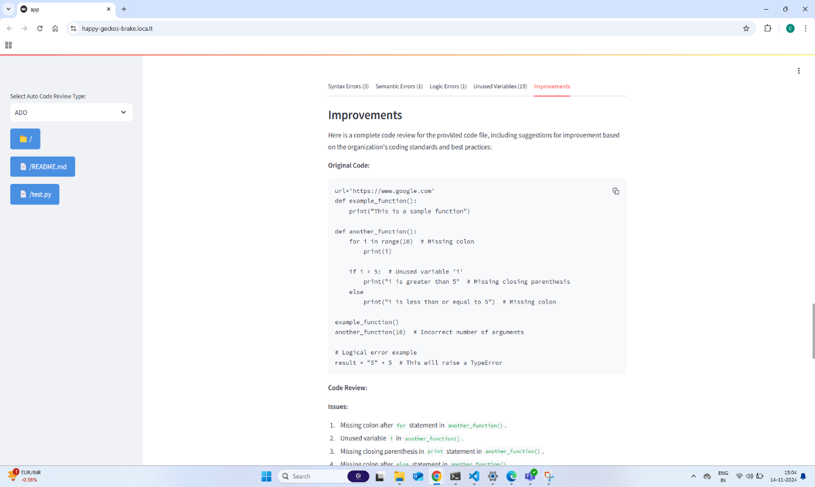

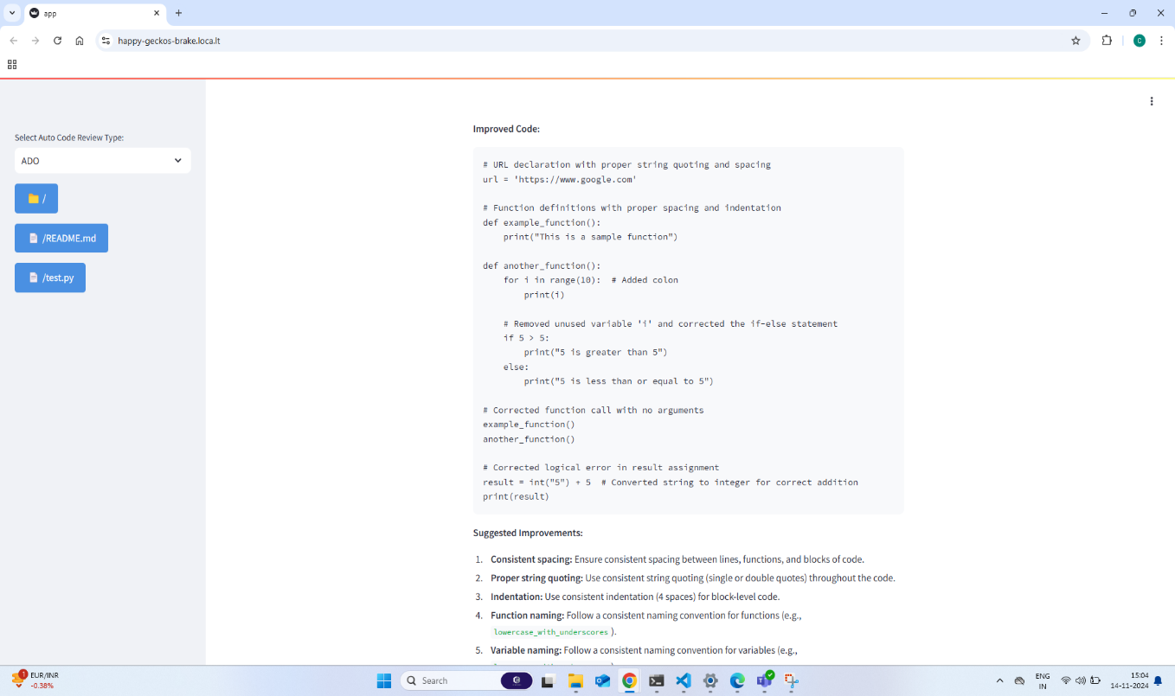

# Appendix

## Environment Variable Configuration

